1. Name of Building or Site
Historic: Downtown Stoughton, Main Street Stoughton
Common: Historic Downtown District
2. Location
Address: 100-200 blocks of E. Main Street and 100 to 500 blocks of W. Main Street
Aldermanic District: |  |  | County: Dane
3. Classification
Type of Property | Ownership |  | Historic Use |  | Present Use
X District | X Public |  | (if different from |  | Agriculture | Museum
Building(s) | X Private |  | present use) |  | X Commercial | Park
Structure |  |  |  |  | X Educational | Private Residence
Site | Status |  |  |  | X Entertainment | Religious
Object | Occupied |  |  |  | X Government | Scientific
 | Unoccupied |  |  |  | Industrial | Transportation
 |  |  |  |  | Military | Other:
4. Current Owner of Property
Name: See the appended list of property owners.
Street Address: See the appended list of property owners.
5. Legal Description (in County Courthouse / City Assessor’s Office)
Parcel Number: N/A
Legal Description: N/A
6. Representation in Existing Surveys
Title/Date/Depository of Survey Records: See bibliography.
7. Description
Condition:
X Excellent Fair |  | X Unaltered |  | X Original Site
X Good Poor |  | X Altered |  | Moved, Date:
Original Owner: See appended building inventory.
Original Use: See appended building inventory.
Architect or Builder: See appended building inventory.
Architectural Style: See appended building inventory.
Date of Construction: See appended building inventory.
Indigenous Materials Used: Brick; Limestone; Sandstone; Terra cotta.
Describe the present and original physical appearance (attach on separate sheets)

8. Significance
Area(s) of Significance – check all that apply and justify in section 7a below
X Architecture

X Cultural or Social History

Associative Significance

Statement of Significance and Conformance to Designation Criteria
(attach on separate sheets)
9. Major Bibliographical References (attach additional sheets if necessary)
City and State Archives:
- Individual property records from the Wisconsin Architecture and History Inventory provided by the State Historic Preservation Office, Wisconsin Historical Society, Madison, Wisconsin.
- Wisconsin Historical Society, Bailey, H. H.(Howard Heston) 1836-1878, Stoughton, Wis. 1871, 22761. Viewed online at https://content.wisconsinhistory.org/digital/collection/maps/id/133/rec/2
- Wisconsin Historical Society, Beck and Pauli Litho, Bird’s-Eye View of Stoughton, 22767. Viewed online at https://www.wisconsinhistory.org/Records/Image/IM22767
- National Register of Historic Places, Stoughton Main Street Commercial Historic District, Stoughton, Dane, Wisconsin, 82001842.
- National Register of Historic Places, Stoughton Main Street Commercial Historic District (Boundary Increase), Stoughton, Dane, Wisconsin, 94000387.

Periodicals, pamphlets, and websites:
The following newspaper archives provided electronically via newspapers.com:
- Wisconsin Enquirer
- Wisconsin Argus
- Wiskonsan Enquirer
- Tri-weekly Argus
- Wisconsin Express
- Wisconsin State Journal
- The Wisconsin Weekly Blade
- The Capital Times
- The Suburban Post

Books:
- Carpenter and Tenney, M. (1851). Statistics of Dane county, Wisconsin: with a business directory of part, of the village of Madison. Madison: Carpenter & Tenney printers.
- Quaife, M. Milton. (1924). Wisconsin, its history and its people, 1634-1924. Chicago: The S. J. Clarke publishing company.
- Butterfield, Consul Willshire. (1880). History of Dane County, Wisconsin ... Preceded by a History of Wisconsin, Statistics of the State, and an Abstract of Its Laws and Constitution and of the Constitution of the United States, Part 1. Madison: Western Historical Company.
- Park, Wm. J., & co. (1877). Madison, Dane County and Surrounding Towns: Being a History and Guide to Places of Scenic Beauty and Historical Note ... Early Intercourse of the Settlers with the Indians ... with a Complete List of County Supervisors and Officers, and Legislative Members. Madison: W.J. Park & Company.

Other:
- Sanborn Fire Insurance Maps for Stoughton, WI 1884, 1887, 1892, 1898, 1904, 1912, and 1926.
- Dane County Atlas Maps 1873, 1890, 1899, 1904, 1911, 1931, and 1954.
- Historic Aerial Maps 1955, 1960, 1969, 1971, 1976, 1980, 1981, 2000, 2005, 2008, 2010, 2013, 2015, 2017, 2018, and 2020.
- City of Stoughton Directories provided in the Kvamme Local History collection of the Stoughton Public Library.
- Historic photographs provided by the Stoughton Historical Society via historicstoughton.org
- Individual Landmark Designation descriptions provided by the Stoughton Landmarks Commission via stoughtonlandmarks.org

- Vintage Stoughton Wisconsin Pictures (Digital Collection).

10. Form Prepared By
Name/Title: Erica Ruggiero/Historic Preservation Specialist
Organization: McGuire Igleski & Associates, Inc. |  | Date: November 10, 2022
Street & Number: 1330 Sherman Avenue |  | Phone: 847.328.5679
City, State, Zip: Evanston, IL 60201 |  | Email: erica@miarchitects.com
11. Commission/Council Actions
Hearing Date: March 9, 2023 |  | Hearing Approved:
Council Designated a Landmark (Date): |  | Landmark Number:
Certified By:
Commission Chairman Name: Date:
Signature:

SUMMARY OF NARRATIVE DESCRIPTION

The Historic Downtown District (HDD) is the original city center for commerce, transportation, education, government, and recreation in Stoughton. The district roughly encompasses the buildings which front East and West Main Street from the Yahara River on the west to Seventh Street on the east. The area that would develop as Stoughton’s Main Street commercial corridor was predominately constructed between 1860 and 1910. During this period, Stoughton developed as a regionally significant mercantile center for southern Dane and northern Rock counties, providing the region with extensive retail, financial, and professional services. These historical uses continue today and are reflected in the district’s diverse buildings and unique streetscape. The district encompasses an architecturally significant collection of Victorian era and early twentieth-century commercial buildings ranging in style from the vernacular Italianate to the exuberant Beaux Arts, and sharing a cohesive unity in scale, material, and detail unsurpassed by commercial districts elsewhere in Dane County.

The HDD is composed of approximately fourteen acres with fifty-seven contributing buildings, two potentially contributing buildings, thirteen non-contributing buildings, one non-contributing vacant lot, and three non-contributing parking lots. The district is also listed in the National Register of Historic Places and has fourteen properties individually designated as local landmarks. The period of significance is from 1860, the construction date of the oldest building in the district, to 1947, the construction date for the last contributing building in the district.

Today, many of the district’s historic buildings retain a high degree of integrity and retain their original exterior materials and character-defining features, which reflect the historic prosperity and important commercial role of the district during its historic period.

___________________________________________________________________________________________________________________
Narrative Description

In 1847, Luke Stoughton platted a community along the Yahara River, the beginning of what we know today as Stoughton. As part of his plat, he laid out Main Street, the primary east-west thoroughfare through the town and the location of the community’s commercial center. By the early 1870s, Main Street developed into a significant retail center for southern Dane and northern Rock counties.

Approximately bounded by the Yahara River on the west and Seventh Street on the east, the Stoughton Historic Downtown District is distinguished by its range of architectural styles, building materials, cohesive height and scale, commercial uses, and pedestrian-scale architecture. This section describes the district’s significant defining features, architecture, and building types that make the district distinctive and visually unique.

The district is distinguished from its adjacent neighborhoods by the prevalence of mixed-use buildings on Main Street in contrast to the solely residential buildings in the neighborhoods to the north and east. Most buildings have first floor storefronts with one or two upper residential or non-retail commercial floors, blending uses and creating an urban and diverse streetscape.

The district is composed of seventy-three buildings, predominately of masonry construction clad in brick and limestone, and four sites, including three parking lots and one vacant lot. Buildings range in height from one to five stories, with seventy-five percent being two stories in height, nineteen percent being one story in height, and the remaining six percent being either three (four percent) or five (two percent) stories in height. The predominately low heights of the buildings create a district with a pedestrian-friendly scale.

District buildings were predominately constructed without setbacks. Buildings with setbacks include the prominent Stoughton City Hall and the Stoughton Post Office. Massing is predominately solid, in the shape of a square or rectangle, with slight deviations from the solid massing through the use of projecting bays or wings, bay or oriel windows, and towers or turrets.
Situated in the Yahara River valley, the topography of the district is relatively flat. There is a gentle incline
eastward on Main Street as the river stretches to the outer edge of the river valley and toward the bluffs. The district is landscaped with mature trees planted at semi-regular intervals along Main Street, west of Fifth Street, and smaller, sporadic immature trees and shrubs along Forrest and Fourth Streets, and no landscaping on Water and Division Streets. Streetlights designed in a historic style are located at regular intervals along Main Street between the Yahara River and just east of Fifth Street.

The district is pedestrian-focused along the north-south streets, which are narrower, while Main Street, the primary east-west arterial, is focused on both vehicular and pedestrian traffic with the greatest roadway and sidewalk widths in the district at forty-eight feet and ten to fourteen feet, respectively, and is landscaped with smaller trees to serve as a buffer between pedestrian traffic on the sidewalk and vehicular traffic on the roadway and at street parking. The width of the north-south streets varies from twenty-eight to forty-two feet, while sidewalk widths only slightly vary throughout the district between five to ten feet wide. The orientation and layout of the streets remain unchanged since the earliest development in the district. Historically, Main Street was wider to allow for larger horse-drawn carriages and ox-drawn wagons, street vendors, and general commercial activities. Today, the extra width has been converted to parallel parking. Additionally, Main Street was designated at U.S. Route 51 (formerly State Trunk Highway 10) in 1926. The highway spans 316.59 miles from Beloit, Wisconsin at its southern terminus to Hurley, Wisconsin at its northern terminus.

The district was also serviced by the Chicago, Milwaukee, St. Paul and Pacific Railroad (CMStP&P, referred to as the “Milwaukee Road”) (formerly known as the Milwaukee and Waukesha Railroad and the Milwaukee and Mississippi Railroad) with freight and passenger stations located approximately one block east of downtown at 529 and 532 E. Main Street. Today, the Wisconsin & Southern Railroad (successor of the Milwaukee Road) provides Stoughton with freight rail transportation with connections to Milwaukee, Janesville, Madison, Oshkosh, Reedsburg, and Chicago and harbor facilities in Prairie du Chien. Passenger services in Stoughton were discontinued in 1989.

The architecture of the district is a tangible representation of the predominant development period and period of significance of the district (c. 1860-1947). Buildings were constructed in popular styles from the development period, including the Italianate, Second Empire, and Romanesque Revival styles prevalent during the mid-to-late nineteenth century and the revival styles popular during the early twentieth century such as Late Classical Revival, Late Gothic Revival, Italian Renaissance Revival, and Art Deco.

The historic built environment of the district remains well intact, and this mixed-scale development, with a focus on the human scale, has been followed and maintained by the limited new construction during the mid-to-late twentieth century.

The individual buildings retain a high degree of architectural integrity and character. Building alterations have been minimal and are localized to the first-floor storefronts and second floor windows. At the first floor, original storefronts and signage have been modernized with new glazing and an aluminum frame. At upper floors, windows have been replaced in-kind, while architectural details, including the cornices, brick pattern or relief work, window trim, bay windows, and stringcourses remain intact and with excellent integrity.

The buildings in the district follow national trends in architectural styles and building typologies popular at their time of construction. Each building reflects its construction date based on architectural details and construction methods. All buildings can be identified by their typology. Typical building typologies found in the district include commercial types such as the one and two-part commercial blocks and auto-oriented typologies, including service/filling stations and automobile showrooms. Furthermore, many buildings can be identified by their architectural style. During the development of the HDD, styles such as Italianate, Romanesque Revival, Late Classical Revival, and Queen Anne, were frequently employed.

The following is an inventory for each of the existing contributing, potentially contributing, and non-contributing resources, including their historic building name or use, if known, address, date of construction, primary architectural style, building typology, architect/builder, if known, and current photograph which corresponds to the photograph log of this nomination. The listed addresses correspond to the addresses listed with the City of Stoughton. A “Building Key” is located in the “Additional Documentation” section of this nomination.

If a building is listed with two dates, the later date is for an addition or remodeling, as noted.

*Abbreviations Note: ARCH: Architectural; AVE: Avenue; BLDG. TYP.: Building Typology; C: Contributing; DIR.: Direction; FF: False-front; GF: Gable-front; NA: Not Applicable; NC: Non-Contributing; NO: Street Number; NR: Individually-Listed in the National Register; OPCB: One-Part Commercial Block; PC: Potentially Contributing; SUF: Suffix; TPCB: Two-Part Commercial Block.

ID | NO. | DIR. | ST. | SUF. | HISTORIC NAME/USE | DATE OF CONSTRUCTION | BLDG. TYP. | ARCH. STYLE/DETAILS | C/  NC | PHOTO NO.
1 | 201 | W | MAIN | ST | HYLAND-OLSEN BLOCK | 1897 | TPCB | COMMERCIAL VERNACULAR WITH ITALIAN RENAISSANCE REVIVAL DETAILS | C
2 | 216-220 | W | MAIN | ST | CONFECTIONARY (FIRST COMMERCIAL USE) | C.1887-1892 | FF | COMMERCIAL VERNACULAR | C
3 | 214 | W | MAIN | ST | BUTCHER (FIRST COMMERCIAL USE) | C. 1887-1892 | FF | COMMERCIAL VERNACULAR WITH ITALIANATE DETAILS | C
4 | 208 | W | MAIN | ST | BAKERY (FIRST COMMERCIAL USE) | C.1887-1892 | TPCB | COMMERCIAL VERNACULAR WITH ROMANESQUE REVIVAL | C
5 | 204 | W | MAIN | ST | AGRICULTURAL IMPLEMENTS (FIRST KNOWN COMMERCIAL USE) | C.1887-1892; C.1905-1912 (BRICK VENEER EXTERIOR APPLIED) | TPCB | COMMERCIAL VERNACULAR WITH LATE CLASSICAL REVIVAL | C
6 | 210-214 | S | WATER | ST | SQUARE DEAL CREAMERY (FIRST COMMERCIAL USE, IF THIS IS THE ORIGINAL BUILDING) | C.1904-1912 | TPCB | NEW TRADITIONAL WITH QUEEN ANNE DETAILS | NC
7 | 211 | S | WATER | ST | THOMAS OSCAR & SON GARAGE AND WORKSHOP | 1919 | TPCB | COMMERCIAL VERNACULAR WITH LATE CLASSICAL REVIVAL | C
8 | 211 | S | WATER | ST | THOMAS OSCAR & SON GARAGE | C. 1912-1919 | TPCB | COMMERCIAL VERNACULAR | C
9 | 220 | S | WATER | ST | BLACKSMITH (FIRST COMMERCIAL USE) | C. 1904-1912 | GF | NO STYLE | NC
10 | 193 | W | MAIN | ST | PATRONS OF HUSBANDRY NO. 267 | 1875 | TPCB | COMMERCIAL VERNACULAR WITH ITALIANATE DETAILS | C
11 | 188 | W | MAIN | ST | ERICKSON BUILDING | 1905 | TPCB | BEAUX ARTS | C
12 | 183-187 | W | MAIN | ST | GROCERY (FIRST COMMERCIAL USE) | C.1892-1898 | TPCB | COMMERCIAL VERNACULAR WITH ROMANESQUE REVIVAL DETAILS | C
13 | 180-184 | W | MAIN | ST | GROCERY (FIRST KNOWN COMMERCIAL USE) | C. 1898-1904 | TPCB | COMMERCIAL VERNACULAR WITH QUEEN ANNE | C
14 | 177 | W | MAIN | ST | MILLINERY (FIRST COMMERCIAL USE) | C.1874-1882 | TPCB | COMMERCIAL VERNACULAR | C
15 | 172-176 | W | MAIN | ST | FURNITURE AND COFFINS (FIRST COMMERCIAL USE) | C.1887-1892 | TPCB | COMMERCIAL VERNACULAR WITH QUEEN ANNE DETAILS | C
16 | 171 | W | MAIN | ST | CITIZENS STATE BANK | 1907 | TPCB | NEOCLASSICAL | C
17 | 168 | W | MAIN | ST | FARM IMPLEMENTS (FIRST COMMERCIAL USE) | C.1892-1898 | TPCB | COMMERCIAL VERNACULAR WITH QUEEN ANNE | C
18 | 159-161 | W | MAIN | ST |  | UNKNOWN (MAY BE AN EARLIER C.1900 BUILDING HEAVILY REMODELED OR A POST-1980 BUILDING) | OPCB | NEW TRADITIONAL | NC
19 | 155 | W | MAIN | ST | SALOON (FIRST COMMERCIAL USE) | C.1898-1904 | TPCB | QUEEN ANNE: FREE CLASSIC | C
20 | 154 | W | MAIN | ST | FARM IMPLEMENTS (FIRST COMMERCIAL USE) | C.1892-1898; C.1898-1904 (LIMESTONE VENEER CLADDING) | TPCB | LATE CLASSICAL REVIVAL | C
21 | 135 | W | MAIN | ST | THREE STOREFRONTS (FIRST FLOOR)/HOTEL ROOMS FOR HUTSON HOUSE (SECOND FLOOR) | C.1892-1898 | TPCB | LATE CLASSICAL REVIVAL | NC
22 | 124 | W | MAIN | ST |  | C.1960-1969 | OPCB | NO STYLE | NC
23 | 101 | W | MAIN | ST | HOTEL KEGNOSA | 1918-1919 | TPCB | COMMERCIAL VERNACULAR | C
24 | 314 | W | DIVISION | ST |  | C.1955-1960 | OPCB | MID-CENTURY  MODERN | NC
25 | 317 | S | DIVISION | ST | TEMPERANCE SALOON WITH DWELLING ON SECOND FLOOR (FIRST USES) | C.1887-1890; POST-1912 (BRICK VENEER APPLIED TO EXTERIOR) | TPCB | COMMERCIAL VERNACULAR | C
26 | 319 | S | DIVISION | ST | PRINTING/GAS ENGINEERING (FIRST COMMERCIAL USE) | 1893 | TPCB | COMMERCIAL VERNACULAR WITH QUEEN ANNE DETAILS | C
27 | 321 | S | DIVISION | ST | SALOON (FIRST COMMERCIAL USE) | C.1892-1898 | TPCB | COMMERCIAL VERNACULAR | C
28 | 100-110 | E | MAIN | ST | SCHELDRUP BLOCK | 1897 | TPCB | QUEEN ANNE | C
29 | 105-111 | E | MAIN | ST | HAUSMANN BREWING COMPANY SALOON | 1903 | TPCB | QUEEN ANNE | C
30 | 113 | E | MAIN | ST | JEWELER/BARBER (FIRST COMMERCIAL USE) | PRE-1871 WITH REMODELED FACADE | TPCB | MID-CENTURY MODERN | PC
31 | 120-130 | E | MAIN | ST | BRICKSON BLOCK | C. 1872-1884 | TPCB | ITALIANATE | C
32 | 121-123 | E | MAIN | ST | CLOTHES, BOOTS & SHOES, CROCKERY, STEAM PRINTING, AND WAREHOUSE (FIRST COMMERCIAL USES) | C.1882-1887 | TPCB | ITALIANATE | C
33 | 129-131 | E | MAIN | ST | HARDWARE STORE (FIRST COMMERCIAL USE) | C. 1872-1882 | TPCB | ITALIANATE | C
34 | 134 | E | MAIN | ST | BOYCE BLOCK | 1905 | TPCB | ITALIAN RENAISSANCE REVIVAL | C
35 | 139-195 | E | MAIN | ST | HAUSMANN-CHRESTOFFER-FORTON-HELLICKSON-MIKKELSON-ERIKSON-JOHNSON BLOCK | 1889 | TPCB | QUEEN ANNE: FREE CLASSIC | C
 | 308 | S | FORREST | ST | ICEHOUSE (FIRST COMMERCIAL USE) | C.1882-1887 |  | UTILITARIAN
36 | 144 | E | MAIN | ST | DRY GOODS (FIRST COMMERCIAL USE) | C. 1870 | TPCB | ITALIANATE | C
37 | 148-154 | E | MAIN | ST | HANS PETERSON BUILDING | 1865 | TPCB | ITALIANATE | C
38 | 160 | E | MAIN | ST | MASONIC HALL | 1869 | TPCB | ITALIANATE | C
39 | 164 | E | MAIN | ST | GROCERY (FIRST COMMERCIAL USE) | C. 1898-1904 | TPCB | ITALIANATE | C
40 | 174 | E | MAIN | ST | O.O. FORTON & CO. (GROCERY AND NOTIONS, FIRST KNOWN COMMERCIAL USE) | PRE-1871 | GF | COMMERCIAL VERNACULAR | C
41 | 176 | E | MAIN | ST | FRANK ALLEN BUILDING | 1859 | TPCB | ITALIANATE | C
42 | 218 | S | FORREST | ST | STOUGHTON FEDERAL SAVINGS & LOAN | 1959 | OPCB | COLONIAL REVIVAL | C
43 |  | E | MAIN | ST | STOUGHTON CITY HALL PUBLIC PARKING LOT | C.1969-1980 | PARKING LOT | N/A | NC
44 | 209-211 | E | MAIN | ST | STOUGHTON STATE BANK (WEST BUILDING)/POST OFFICE WITH STOREFRONTS (EAST BUILDING) | 1878 (BANK/WEST BUILDING); C. 1904-1912 (POST OFFICE/EAST BUILDING) | TPCB | MID- CENTURY MODERN, HISTORICALLY THE BANK BUILDING WAS ITALIANATE AND THE POST OFFICE BUILDING WAS COMMERCIAL VERNACULAR | PC
45 | 225-229 | E | MAIN | ST | PHOTOGRAPHY STUDIO (FIRST COMMERCIAL USE) | C.1898-1904 | TPCB | NO STYLE | NC
46 | 243 | E | MAIN | ST | HARNESS SHOP/HOME BAKERY (HANS ROMNES FAMILY) | C.1882-1887 |  | NO STYLE | NC
47 | 246 | E | MAIN | ST | UNITED STATES POST OFFICE STOUGHTON WISCONSIN #53589 | 1936 | OPCB | ART DECO | C
48 | 255 | E | MAIN | ST | BADGER THEATRE | 1921 | VAULT | BEAUX ARTS | C
49 | 288 | E | MAIN | ST | ROE BUILDING (ROE AUTOMOBILE COMPANY) | 1913 | SHOWROOM | LATE CLASSICAL REVIVAL | C
50 | 304 | S | FOURTH | ST | CARNEGIE PUBLIC LIBRARY | 1907; 1990 (ADDITION) | LIBRARY | NEOCLASSICAL | C
51 |  | E | MAIN | ST | CITY OF STOUGHTON PUBLIC PARKING LOT | c. 1981-2000 | PARKING LOT | N/A | NC
52 | 315 | E | MAIN | ST | N/A | c. 2018-2021 | VACANT LOT | N/A | NC
53 | 334 | E | MAIN | ST | DWELLING | C.1874-1882 HIGHLY-REMODELED DWELLING LATER CONVERTED TO A BOARDING HOUSE (1904 SANBORN MAP) AND THEN STORE (1912 SANBORN MAP); C.2007-2011 (FAÇADE REMODELING) | FF | NEW TRADITIONAL | NC
54 | 340 | E | MAIN | ST |  | C. 1912-1926; SECOND FLOOR REMOVED AND FAÇADE REMODELED AT AN UNKNOWN TIME | OPCB | NO STYLE | NC
55 | 341-345 | E | MAIN | ST | O.F. TIPPLE STABLE/LIVERY WITH DWELLING ON SECOND FLOOR | 1891 | TPCB | COMMERCIAL VERNACULAR WITH ITALIANATE DETAILS | C
56 | 348-356 | E | MAIN | ST | PHOTOGRAPHY STUDIO (FIRST FLOOR)/Y.W.C.A (LATER W.C.T.U.) (SECOND FLOOR) | C.1892-1898 | TPCB | QUEEN ANNE | C
57 | 355-357 | E | MAIN | ST | TEMPERANCE SALOON AND DWELLING | 1891 | TPCB | ROMANESQUE REVIVAL | C
58 | 364 | E | MAIN | ST | HOSE CARTS (FIRST COMMERCIAL USE) | 1884 | TPCB | ITALIANATE | C
59 | 374 | E | MAIN | ST | TURKISH BATHS (FIRST COMMERCIAL USE) | C.1887-1892 | TPCB | COMMERCIAL VERNACULAR | NC
60 | 381 | E | MAIN | ST | STOUGHTON CITY HALL, LIBRARY, AND AUDITORIUM | 1900 | CITY HALL | ROMANESQUE REVIVAL | C
61 | 384 | E | MAIN | ST | GENTLEMEN'S STORE (FIRST COMMERCIAL USE) | C.1904-1912 | TPCB | QUEEN ANNE | C
62 | 388 | E | MAIN | ST |  | C. 1874-1882 | TPCB | ITALIANATE | C
63 | 381 | E | MAIN | ST | STOUGHTON OPERA HOUSE PARKING LOT | c. 2005-2008 | PARKING LOT | N/A | NC
64 | 401 | E | MAIN | ST | N/A | 2007 | CITY HALL | NEW TRADITIONAL | NC
65 | 419 | E | MAIN | ST | CARL ELLINGSON SALOON (TEMPERANCE SALOON) | 1891 | TPCB | COMMERCIAL VERNACULAR WITH SECOND EMPIRE DETAILS | C
66 | 421-427 | E | MAIN | ST | HANSON HOUSE/GRAND HOTEL | 1891; C.1926 (ADDITION) | TPCB | ITALIANATE | C
67 | 435 | E | MAIN | ST | ROBERT VAN ETTEN SERVICE STATION | 1947 | SERVICE STATION | COMMERCIAL VERNACULAR | C
68 | 480 | E | MAIN | ST | ABE HOLTAN SERVICE STATION | 1939 | SERVICE STATION | ART MODERNE | C
69 | 201 | S | SIXTH | ST | LAUNDRY (FIRST COMMERCIAL USE) | C.1887-1892 | GF | NO STYLE | NC
70 | 210 | S | SIXTH | ST | STORAGE | C. 1900 | GF | COMMERCIAL VERNACULAR WITH ITALIANATE DETAILS | C
71 | 500 | E | MAIN | ST | STOUGHTON BUICK CO. GARAGE AND SHOWROOM | 1916 | GARAGE AND SHOW-ROOM | COMMERCIAL VERNACULAR | C
72 | 501 | E | MAIN | ST | DOUGHBOY FEEDS | 1927 | OPCB | ART MODERNE | C
73 | 508 | E | MAIN | ST | PABST BREWING CO. SALOON BUILDING | 1902 | TPCB | LATE GOTHIC REVIVAL | C

Today, the Stoughton Historic Downtown District remains intact and appears much as it did when fully developed at the end of the period of significance (c. 1860-1947). The majority of the properties are intact and have sustained little if any, exterior modifications. Most alterations visible from the public right of way, are window and door replacement, installation of contemporary storefronts, window infill, and, less frequently, new brick veneer cladding or synthetic siding at the front façade. Of the seventy-three buildings in the district, thirteen buildings were identified as non-contributing, nine of which were constructed during the period of significance (1860-1947), but lack architectural integrity, and five were constructed outside of the period of significance. There are also four non-contributing sites, three parking lots, and one vacant site following the demolition of a historic building at 315 E. Main Street.
Two buildings have been identified as potentially contributing including the former Stoughton State Bank and Post Office building located at 209-211 E. Main Street and 113 E. Main Street. Historically, 209 and 211 E. Main Street were two separate buildings when they were constructed in 1878 and c.1905, respectively. Following the end of the period of significance (c. 1860-1947), the two buildings were consolidated into one storefront, and a metal slipcover was installed to unify and modernize the second floor façades of each building. Based on field observation, the original second floor of at least the Stoughton State Bank building remains intact. Likewise, a slipcover was added to the front façade of the building at 113 E. Main Street, though it is unknown if the original façade remains intact. Both buildings may become contributing to the historic district if the slipcovers are removed and the historic façades are restored.

SUMMARY OF STATEMENT OF SIGNIFICANCE

Encompassing over 160 years of history and development, the Historic Downtown District (HDD) endures as a locally significant commercial district and the heart of commerce, government, society, transportation, education, and local community culture for the City of Stoughton since its founding in 1847. The period of significance is from 1860-1947, reflecting the date of construction of the oldest building in the district, up until the construction date of the last contributing building.

Under Sec. 38-34. - Landmark and landmark site designation criteria of the City of Stoughton Code of Ordinances the Historic Downtown District is eligible for local landmark designation under Criteria #1 as it exemplifies the cultural, political, economic, and social history of the city, Criteria #3 as it embodies distinguishing characteristics or an architectural type, valuable for a study of a period, style, construction method or indigenous materials or craftsmanship, and Criteria #6 as it provides an example of the physical surroundings in which past generations lived.

The following sections will provide a historical narrative of the district’s contribution and local significance to the City of Stoughton in the realms of commerce and trade, government, education, transportation, and entertainment.

____________________________________________________________________________________________________________________

NARRATIVE STATEMENT OF SIGNIFICANCE

PRE- HISTORY AND EARLY SETTLEMENT OF WISCONSIN
Native people have occupied the area now known as Dane County for nearly 12,000 years BP (Before Present). Prior to the arrival of European settlers from the seventeenth through the nineteenth centuries, this region was also home to people from Anishinaabe groups like the Ojibwe, Potawatomi, and Odawa, other Algonquian speakers such as the Kickapoo, Sauk, and Meskwaki (Fox), as well as Siouan-speaking groups including the Ho-Chunk (Winnebago).

As the burgeoning United States headed west at the beginning of the nineteenth century, the government attempted to buy Native American-owned lands as part of the expansion. In 1804, territorial governor William Henry Harrison negotiated a treaty with Sauk and Meskwaki leaders to purchase their lands east of the Mississippi River. The treaty allowed the tribes to inhabit and use the lands until it was surveyed and sold to settlers. The Sauks continued to live on their lands and in their village of Saukenuk for the next two decades.

After the War of 1812, the promise of fertile lands and the beauty of the landscape attracted early pioneers to the valleys of the Mississippi and Rock Rivers. The United States government began establishing a chain of western frontier defenses including Fort Armstrong (1816, near present-day Rock Island, Illinois), Fort Platteville Blockhouse (1827, near Platteville), and Fort Winnebago (1828, Portage), but it wasn’t until 1828 that the government began surveying the land ceded in 1804.

The Sauks were officially informed in 1828 by government agent Thomas Forsyth that they were to vacate Saukenuk (present-day Rock Island, Illinois) and their other settlements east of the Mississippi River. When the time came, many Sauks had chosen to cede their lands and relocate west of the Mississippi River, rather than risk a confrontation with the United States.

Roughly 800 Sauks, led by Sauk band leader and warrior Black Hawk, chose to stay on their native lands and resist the United States’ westward expansion. They were determined to protect Saukenuk, but when his group returned to the village after their winter hunts in 1829-1831, they found their village increasingly occupied by (white) squatters. Their homes claimed by white settlers, their corn hills used as storage for wagons, and the bones of their ancestors disturbed and laid bare upon the ground by the plow.

United States officials were determined to force the Sauk tribe out of Illinois and southwestern Wisconsin. Under General Edmund P. Gaines, a full assault was launched against Saukenuk on June 26, 1831, only to find that Black Hawk and his followers had abandoned the village and crossed the Mississippi River. Additional forts were added to the line of frontier defenses including Fort Koshkonong (1832, Atkinson), Fort Union (1832, Dodgeville) Rountree's Fort/Fort Dodge
(1832, Platteville).

In April 1832, Black Hawk prepared to re-cross east of the Mississippi River leading a faction of Sauks, Meskwakis, and Kickapoos, east of the Mississippi and into the American state of Illinois, from Iowa Indian Territory. While Black Hawk's exact motives were unknown, the presence of children, women, and elders indicated that they were a peaceful party, only hoping to resettle on their native lands.

Convinced that the group was hostile, a frontier militia was organized and opened fire on the group on May 14, 1832. The group responded with a successful attack on the militia at the Battle of Stillman's Run. Black Hawk led his faction to a safe location in southern Wisconsin. Under the command of General Henry Atkinson, the U.S. troops tracked the group to Wisconsin. On July 21, they were defeated by Colonel Henry Dodge’s militia at the Battle of Wisconsin Heights. Weakened by starvation and death, survivors retreated toward the Mississippi River.

Simultaneous with the Black Hawk War of 1832, the Ho-Chunk Nation was removed from Wisconsin and Illinois between 1832-1874 following the Winnebago War of 1827. The war was more or less limited to a series of skirmishes led by the Ho-Chunk Nation as lead miners continually trespassed on their land, and in reaction to a rumor, later revealed as false, that the United States had sent two Ho-Chunk prisoners to a rival tribe for execution. Neighboring tribes in the region did not join the Ho-Chunk in the conflict, and the tribe was outnumbered by the United States military which included 600 troops from St. Louis and hastily formed local militia units assembled at Prairie du Chien, as well as an additional 100 troops at Green Bay which were joined by 125 Menominee, Oneida, and Stockbridge warriors. In late August the troops from Prairie du Chien and Green Bay converged on the Ho-Chunk which were assembled in Portage. Ho-Chunk chiefs surrendered eight men who had initiated the attacks on white settlers, including warrior Red Bird, who was believed to be the leader.

As a result of the conflict, the Ho-Chunk Nation ceded their land and the lead mining region to the United States and were moved north and west into present-day Minnesota, Iowa, and Nebraska. The Ho-Chunk refused to live on the increasingly infertile lands away from their abundant homelands in Wisconsin. Many returned to Wisconsin and joined those who refused to leave, to purchase back their land in their ancestral home under the 1862 Homestead Act. This act of strength and resilience would lead to a new national law, the Indian Homestead Act of 1875, and a nation of over 10,000 citizens today.

CREATION OF DANE COUNTY AND THE FOUNDING OF THE CITY OF STOUGHTON
Following the end of the Black Hawk War, the Wisconsin Territory was established in 1836. Initially, the territory included the areas of the present-day states of Wisconsin, Minnesota, and Iowa, and part of the Dakotas east of the Missouri River. In the Wisconsin Territory, Dane County was formed in 1839 from the western part of Milwaukee County and the eastern part of Iowa County. Situated near the center of the state near the midway point between Lake Michigan and the Mississippi River, Dane County is bounded by Columbia and Sauk Counties on the north, by Rock and Green Counties on the south, on the east by Dodge and Jefferson Counties, and on the west by Iowa County. The county was named after Nathanial Dane, a lawyer and statesman who represented Massachusetts in the Continental Congress (1785-1788) and who most notably helped to write the ordinance establishing the Northwest Territory and the amendment which prohibited slavery in the territory.

The future site of the City of Stoughton would be situated in Dunkirk Township, located in the north southeastern part of Dane County. It is one of the original towns from when the County was organized in 1846. The area was settled for its fertile and productive stands of oak, prairies, and marshes and the opportunities afforded by the Yahara River including hunting, fishing, and waterpower. The first settler in the area was John Nelson, a Norwegian, in 1843. Nelson was followed by John Wheeler, the Saunders family, John Estes, Levi Farnham, Joseph Vroman, Joseph Cannon, and John Blake.

The development of Stoughton’s commercial corridor along Main Street dates to the founding of the City in the early nineteenth century. Bisected by the Yahara River and surrounded by the fertile prairies of southern Dane County, the site possessed considerable natural advantages to attract both settlers and commerce. First surveyed by the federal government in 1833, the land that would become the present-day city of Stoughton was first removed from U.S. Government holdings in 1836 by The Western Land Association. In August 1838, the association sold the land to U.S. Senator Daniel Webster who appears to have lost it through non-payment of taxes. In 1841 Herman Cope and Thomas S. Taylor purchased land from the Territory of Wisconsin at a tax deed sale, as well as a warranty deed from Daniel Webster. On July 3, 1847, Luke Stoughton bought the land, approximately 800 acres, from Cope and Taylor for $2,100. The village of Stoughton was platted by Luke Stoughton in 1847 and included the area bounded by Main, Jefferson, Washington, Page, Water, Division, and Forest Streets.

Within a few years, Stoughton harnessed the power of the Yahara River (then known as Catfish Creek), by building a dam, sawmill, and grist mill. In 1847, Alvin West was the first person who settled his family in Stoughton. The family’s first home was also the first commercial building, an inn, in the city. From here, initial development and growth continued at a slow pace. It was not until the following year that Wisconsin became the 25th state to join the Union in 1848.

By 1850, the population was seventy people, and the commercial corridor was composed of only a handful of stores. That same year, Stoughton constructed a gristmill. Three years later, the Milwaukee and Mississippi Railroad reached Stoughton, and by 1855 there were two general stores and two hotels in Stoughton. Despite this burst of commercial and economic development, the community could not counter the Depression of 1857 and nearly all of the stores (which had increased from two to twelve) closed. Additionally, around this time, a new gristmill had been built to serve the community and it fell after being undermined by water rats. Regardless of these challenges, the community rebounded during the following decade and was incorporated as a village in 1868, before being chartered as a city in 1882. As noted in the 1880 History of Dane County, the community was regarded as "first in commercial importance in the county" outside Madison.

The key to success lay in the power of the Yahara, the fertile farmlands which had attracted Yankee and Norwegian farmers throughout the mid-nineteenth century, and the arrival in 1853 of the Milwaukee and Mississippi Railroad (MMR) which made Stoughton an important shipping center for the wheat farmers who dominated the local economy.
During this period of growth and stabilization, the pattern of development was well established by the time the first Bird's Eye View of Stoughton was published in 1871. The commercial core was clearly established along Main Street from the river east to Division Street. For the ensuing two decades, the commercial corridor continued to expand eastward, and by 1892 it covered not only the original blocks between the Yahara River and Division Streets but continued on to Fifth Street.

As the surrounding land was cleared, the cut timber was brought to the mill and was used to construct the first generation of Stoughton's commercial and residential buildings. Included in these early buildings were a general merchandise store on what is now the northwest corner of Main and Division Streets (demolished) and Alvin West’s inn at the southwest corner of the same intersection (demolished).

DEVELOPMENT OF DOWNTOWN STOUGHTON
The Historic Downtown District (HDD) is locally significant as the original and only center of commerce, government, entertainment, and transportation in the City of Stoughton. The following sections illustrate each Area of Significance (AOS) as it relates to the historic context of Stoughton and provides examples on how the built environment of the district developed and transformed relevant to each AOS. The district is also locally significant for architecture. As the city center for Stoughton, the HDD retains a significant collection of the best examples of commercial, governmental, and transportation high-style architecture in the city. More information is provided in the “Architecture of the Stoughton Downtown District” section of this nomination.

COMMERCE AND TRADE IN STOUGHTON

In 1848, Stoughton opened a general store (demolished) across Main Street from Alvin West's inn at the southeast corner of Main and Division Streets. Within the decade, there were two general stores and two hotels in the city. Although the railroad reached Stoughton on December 15, 1853, it could not counter the Depression of 1857 and nearly all of the stores (which had increased from two to twelve) closed. Despite this setback by the early 1870s, Stoughton was recognized as a considerable business center and a historically significant retail center for southern Dane and northern Rock counties outside of Madison, and the second commercial center in the County. At the beginning of the following decade, an estimated eighty-five stores and offices were operating within the community.

Stoughton's commercial growth was based on serving its agricultural hinterland. Wagonmaking provided a vital product for wheat farmers and became a locally important industry in the 1860s when T. G. Mandt, a Norwegian immigrant, developed a wagonmaking facility. Despite the depression of the early 1870s, the Mandt works (one of three wagon-making facilities in the village) had expanded to include fifteen buildings covering seven acres in 1880, located several blocks south of the Main Street commercial corridor. The Mandt works were a tonic to the village's economy: in 1880, the company produced 5,000 wagons, 1,000 buggies, 50,000-75,000 hubs, and thousands of spokes, agricultural implements, and repairs, employing nearly 200 men.

Stoughton's economy, and the health of its commercial district, received another boost during the same period when the city became the center for the local tobacco trade, which replaced wheat as a profitable and popular cash crop. In 1871, Matthew Johnson brought the first tobacco crop to the Stoughton market, and by 1882 nine warehouses, predominately located just east of the commercial corridor, rivaled those of the neighboring community of Edgerton, bringing considerable business and traffic to Stoughton’s Main Street.

The district's prosperity is reflected in the historic and present-day built environment. Between 1870 and 1910, historic maps illustrate an increasingly substantial and denser commercial corridor along Main Street, teeming with doctor offices, drug stores, printing presses, grocers, photography studios, hotels, meat markets, dry goods stores, hardware stores, restaurants, and saloons and later temperance saloons. By 1884, there were thirty-two business buildings along Main Street. In two decades, a total of seventy-six business buildings lined Main Street stretching from the Yahara River to the railroad tracks.

The prosperous, growing economy required local financial resources, and the community's first bank was the Stoughton State Bank. Founded in 1877 by George Dow and H.H. Giles, they built the bank’s first building in 1878 at the southeast corner of Forrest and Main Streets (extant, altered with a slipcover). The Dane County State Bank was Stoughton’s second bank, founded in 1883, and located in the Williams Block (demolished, 124 W. Main Street). An additional extant bank building in the district is the Citizens National Bank building located at 171 W. Main Street (1907).

By 1880, Stoughton was noted as "first in commercial importance in the county,” a title that attracted visitors from across the region. To serve visitors, hotels were established along Main Street including the Hutson House at 101 W. Main Street, the National Hotel (demolished, 480 E. Main Street), and the Hanson Hotel (421 E. Main Street).

As the corridor grew, the first frame commercial buildings were slowly replaced with the existing brick buildings which line Main Street today. Improvements in the corridor’s streetscape and utilities were completed including the installation of telegraph lines in 1884 and the establishment of the first telephone system in 1891 by the Wisconsin Telephone Company (WTC). Following the success of the WTC, the company moved its central office from the Hyland-Olsen Block (1897, 201 W. Main Street) to the Stoughton State Bank building (1878, 211 E. Main Street) in 1905.
That same year, the significance of telephone access was of such importance that the City Council required telephones to be installed in the homes of the mayor and the street commissioner.

The population grew as well, climbing from less than 1,000 in 1870 to almost 5,000 by 1905. To serve the burgeoning population, the district not only served as a local and regional commercial center, but as a social, educational, entertainment, transportation, and governmental center of Stoughton. Commercial buildings, with first floor storefronts, housed fraternal halls, social/assembly halls, and clubrooms on the upper floors including the extant Boyce Block, Masonic Hall, the Hyland-Olsen Block, and the Hausmann-Chrestoffer Block.

EDUCATIONAL BUILDINGS
In the district, lending library and educational activities were evident beginning with the reading room run by the Women's Christian Temperance Union (WCTU) in 1882. For two dollars a year, residents could borrow one of the twenty-five books available in the reading room. The WCTU first managed a reading room in the basement of "Dow's Bank" located in the district at 211 E. Main Street. Later, the WCTU ran reading rooms, at times with the YMCA, at various locations including in the east half of 120-130 E. Main Street and 348-354 E. Main Street, before the library found a home in City Hall at 381 E. Main Street from 1901 to 1907.

Despite finding a permanent home in City Hall, the Library Board, the Stoughton Women’s Club, and other community organizations dreamed of a spacious and accommodating freestanding library building and turned their attention toward steel magnate and philanthropist, Andrew Carnegie.

Beginning in 1898, Andrew Carnegie offered grants for the construction of a library to any community that would provide a site and agreed to tax itself for support. When a town submitted a grant inquiry, a simple questionnaire was sent for completion, asking a few questions about the town name, population, site available, and taxes, and if approved Carnegie would gift $10,000 to construct a single-story library, styled to local taste. Regardless of the $10,000 maximum, the Stoughton Library Board petitioned Carnegie for a $15,000 grant. After much correspondence about specific details, Carnegie granted a compromise of $13,000.

The citizens of Stoughton got to work hosting one fundraising benefit after another, including 15-cent baked bean suppers, home talent plays, and concerts by local musicians, to raise the last few thousand dollars for the proposed library and its furnishings. The city purchased the lot at the southwest corner of Main and Fourth Streets for $4,000 and hired architects Louis Claude and Edward Starck to design the building and local contractor Fred Hill to build it.

The new library was dedicated on March 6, 1908. In total, the library and furnishings cost $21,000 and included solid oak woodwork, shelving, tables and chairs, light fixtures, card catalog files, and a special “men’s room” where male members of the community could go in their work clothes to read and smoke. The library’s popularity quickly grew, with more than 300 hundred books drawn on any one Saturday alone. A popular collection of the library’s large selection of prose and poetry in Norwegian, in addition to popular individual books on history, travel, natural history, and science. Many books were donated by local residents and community organizations. By 1910, the new library housed more than 3,500 volumes and boasted an annual circulation of 17,000.

In 1917, the library became a center for the community’s war efforts, as hundreds of books and magazines were collected, packed, and sent to army camps for the National Library Fund. During the Great Depression (1929-1939), the library experienced a rapid rise in borrowers as citizens who had lost their job, now filled their time with books for education and pleasure. Circulation declined during the mid-twentieth century, but by 1979 circulation showed a dramatic increase, resulting in an addition to the library by architect Ross Potter, completed in 1988, and remodeling of the original building.

The public library building stands as a handsome and excellent example of the Neoclassical style in the district. It represents the determination and attention to education by the citizens of Stoughton. Its location in the central business district, the heart of the city, denotes its importance as a prominent intellectual center of Stoughton.

SOCIAL AND ENTERTAINMENT BUILDINGS
The district is the heart of recreational and social activities of the city. In the district, many of the upper floors of the multi-story commercial buildings served as social halls or headquarters for fraternal organizations, unions, and associations. Buildings that housed halls above the first floor storefronts in the district include the Hyland-Olsen Block (1897, 201 W. Main Street) and the Masonic Hall (1869, 160 E. Main Street).

The district has also been the center of entertainment for the community for over 150 years, but today the commercial corridor retains one specialized entertainment building from the period of significance, the Badger Theatre located at 255 E. Main Street.

Prior to the Badger Theatre, the Williams Block (demolished, site of 124 W. Main Street), also known as the Opera House, was the first building constructed with space dedicated to the performing arts. It was built in 1868 by Nelson Williams, who came to Stoughton in 1859 and married Huldah Delette Stoughton, the second daughter of Eliza Page and Luke Stoughton. In 1904, the building was remodeled and the second floor was converted to office space, and the third floor was created from the gallery and used as a public meeting space for clubs and lodges. The construction of the new City Hall (381 E. Main Street) in 1901, which had a large auditorium, probably caused too much competition for the older Opera House and surpassed the older building as the location of plays, concerts, and graduations. Movies were also shown in the City Hall Auditorium beginning in 1910.

As entertainment and technology developed, Jacob Moelk opened the first moving picture theater in Stoughton in 1908. Named the Lyric (demolished), it was located on the site of present-day 110 E. Main Street. Shortly after, Moelk opened another theater (demolished) at present-day 105-111 E. Main Street. Both were run as nickelodeons, in addition to the Globe Theater (155 W. Main Street) and the Princess Theater (143 W. Main Street). Moelk later opened the community’s first movie theater in 1913 and sold it in 1916 to Charles Guelson, a clothing salesman for the Department Company Store, who would later be the lead developer of the Badger Theatre.

In 1920, Guelson and Gustave Roe (of Roe Auto Company) purchased and demolished the Beardsley House at 255 E. Main Street. Roe was the son of prominent Stoughton citizen Ole K. Roe, who was active in the local tobacco business and was Mayor of Stoughton from 1896 to 1901. The site was chosen for the natural slope of the land, which accommodated the construction of the sloped floor of the new theater. Construction for the Badger Theatre began in April 1920, and it opened for business in March 1921. The earlier movie houses were gone by November 1929, when the Badger opened the first "talkie" in town.

The theater was called the Badger until sometime between 1979 and 1990, when the name was changed to the Cinema Cafe. In 1999, the Stoughton Village Players (SVP), a community theater group formed in 1972, was offered the use of the old Badger Theatre until their home in the Stoughton Opera House was available again following a full remodeling of the building. SVP’s move to the Badger Theatre was meant to be temporary, but after five very successful years of staging over a dozen shows in the space, the group decided to make this arrangement permanent.

Once SVP was permanently situated in the former Badger Theatre, the group undertook the restoration of the exterior façade and interior renovations, including re-finishing the interior, refurbishing all theatrical lights, constructing a stage extension, and adding new seats with aisle lights. SVP continues to operate out of the historic theater, offering a communal performance space for live drama, comedy, and music while fulfilling the artistic needs of the community.

GOVERNMENTAL BUILDINGS
Since Stoughton’s founding, Main Street has been the location of local government offices. Previously part of Dunkirk Township, Stoughton was incorporated as a Village in 1868. On February 6, 1882, the City Charter was adopted. At that time, the governmental structure changed from a Board and President to a Council and Mayor. Services provided by the city government have included fire protection, water supply, sewer service, police protection, street maintenance, and licensing. The original site of local government offices is unknown.

From 1884 to 1901, municipal services were conducted in the second story of the building at 355-357 E. Main Street. On September 7, 1899, the Stoughton City Council voted to purchase three lots on Main Street for a new City Hall and Fire Station (381 E. Main Street). On April 2, 1900, the City Council accepted plans and specifications for the new City Hall done by F. Kemp of Beloit. The following month a bid from Bonnett, Michie & Co. was accepted for the construction of the building. City Hall was completed and dedicated in February 1901.

Additionally, Stoughton has been the site of the local post office since 1848. In 1881, the post office was relocated to the east side of the Williams Block (demolished, 124 W. Main Street). Between 1904 and 1912, the post office moved to the eastern storefronts of 211 E. Main Street, before moving again to its present location at 246 E. Main Street in 1938, designed by Louis Simon, Treasury Department architect. During the Great Depression (1929-1939), the federal government funded several Public Works Administration (PWA) and Works Progress Administration (WPA) projects. In Stoughton, many smaller projects were completed, but the most prominent is the mural completed on the west wall of the post office lobby. The mural depicts "Air Mail" and was painted by Edmund Lewandowski.

RAIL AND ROAD IN STOUGHTON
With the arrival of the Chicago, Milwaukee, St. Paul and Pacific Railroad (CMSTP&P, formerly the Milwaukee and Mississippi Railroad (MMR)) in 1853, Stoughton became a major transportation center locally and for the region – and several extant buildings immediately outside and within the district represent the adapting transportation methods during the period of significance.

Better known as the Milwaukee Road, the granger would one day stretch from Louisville (Kentucky) to Puget Sound, with a nearly 11,000-mile network that served every major Midwestern market directly, with the exception of St. Louis. The CMSTP&P dates back to the Milwaukee & Waukesha Railroad, later the Milwaukee & Mississippi (M&M) Railroad, chartered in 1847 to connect Milwaukee and Waukesha with the Mississippi River.

After near bankruptcy at the beginning of the 1850s, the line acquired the capital needed to reach Madison (1854) and Prairie du Chien (1857). The success of the railroad was short-lived, as the company entered receivership in 1860 after the Panic of 1857. The assets were sold a year later and reorganized as the Milwaukee & Prairie du Chien Railway (M&PDC) in January of 1861. Eager to enter the railroad business, Milwaukee’s leading banker, Andrew Mitchell, organized the Milwaukee & St. Paul (M&STP) in May of 1863. Over the next four years, Mitchel was able to acquire the
M&PDC, the La Crosse & Milwaukee, and the McGregor Western Railroad creating an 800-mile network connecting Milwaukee, Madison, and Prairie du Chien; Minneapolis and Milwaukee; and Portage and La Crosse.

During the following decade, the M&STP rapidly expanded. In 1872 it acquired the St. Paul & Chicago, which followed the west bank of the Mississippi River into the Twin Cities. A year later, the M&STP reached Chicago, and in February of 1874, the name was changed to the Chicago, Milwaukee & St. Paul Railway (CM&STP). By 1876 the company operated more than 1,400 miles and owned five grain elevators in Milwaukee, which could handle 3 million bushels of wheat. As the CM&STP continued to flourish, it reached Iowa, the Dakota Territories, and additional points in Minnesota and Wisconsin. Four years later, the system totaled 3,894 miles. On the horizon was an extension, due west of Chicago, towards the transcontinental gateway of Omaha, Nebraska. In 1882 it arrived in Council Bluffs, Fargo in 1884, and
attained a connection to Kansas City by 1887. At the close of 1887, the network reached an astounding 5,670 miles.

In 1890 the CM&STP had gross revenues of $26.4 million and spent that decade upgrading and modernizing
its property. In September, it acquired the Milwaukee & Northern Railroad, further diversifying its traffic
base by serving the iron ore industry of Michigan's Upper Peninsula. The company began its push to the Pacific in 1899. The entire Pacific Coast Extension was finished in just three years with the "Last Spike" ceremony held at Garrison, Montana, on May 19, 1909. Once opened, the CM&STP’s “Lines West” added 2,159 miles to its network. Within the decade, it boasted a network of 10,257 miles. At the beginning of the 1920s, the line made two final acquisitions, the 373-mile Chicago, Terre Haute & Southeastern in June 1921 (leased) and the Chicago, Milwaukee & Gary in January 1923. The former served the coal mines throughout southern Indiana, and the latter acted as a Chicago belt line.
The company entered a short-lived bankruptcy in March 1925, which lasted less than three years when it was reorganized as the Chicago, Milwaukee, St. Paul & Pacific Railroad (CMSTP&P), which took control of the 11,252-mile system on January 13, 1928. Success was short-lived as the line entered bankruptcy again on June 29, 1935, as The Great Depression languished over the nation. It would not exit receivership until February 23, 1945, with the traffic resurgence of World War II. Over the next decade, the line worked to upgrade its property by laying heavier rail, upgrading freight yards/terminals, and becoming fully dieselized/electrified.

Despite the railroad’s success, it could not surmount its competitors. The CMSTP&P freight revenue density (tonnage divided by total system mileage) was only 1.59 million compared to the Burlington Route’s 2.41 million, Great Northern's 2.34 million, and Northern Pacific's 2.12 million. In addition, its income, excluding fixed charges, was around 1.46 times its financial commitments and quite low when compared to the Great Northern (4.22), Burlington (3.24), and Northern Pacific (3.03). The CMSTP&P’s major drawback was the network of short lines throughout the Midwest, a region
replete with railroads, as well as a subsequent plan to defer maintenance. Though the company experienced net earnings in 1973 and 1974, management refused to spend the necessary capital to maintain the system.

With the unwillingness to spend the necessary funds to meet service demands and a concentrated effort on deferring maintenance, the Milwaukee Road finally filed for bankruptcy on December 19, 1977. Over the decade, 1,100 miles of track were torn up and scrapped. The now much smaller company became a merger target and was acquired by the Soo Line in 1985.

There are no buildings in the Historic Downtown District related to Stoughton’s significant railroad history. Just outside the eastern boundary of the Main Street National Register Historic District are two extant Chicago, Milwaukee St. Paul and Pacific Railroad freight and passenger depots at 529 and 532 E. Main Street and constructed in 1885 and 1913, respectively. Both are designated Local Landmarks and listed in the National Register Depot Hill Historic District.

STOUGHTON’S SHIFT FROM RAIL TO AUTOMOBILE
Based on the existing auto-related buildings in the Historic Downtown District, the shift toward the automobile began as early as 1909 and peaked between the mid-1920s and mid-1940s. Prior to the arrival of the automobile in Stoughton, the city had a prominent commercial livery enterprise and wagon manufacturing industry. The emergence of automobiles and tractors brought about the demise of the wagon factories and the rise of automobile garages, service stations, and showrooms.

Within the district, two prominent transportation-related buildings include the O.F. Tipple Building (341 E. Main Street) and the Roe Building (288 E. Main Street). Tipple established a livery business prior to 1882, which he operated out of this location on Main Street. In 1891 a large fire destroyed Tipple's first livery barn. In September of that year, Tipple began constructing the extant building on the site today. After Tipple, the building continued with various owners as a livery into the early twentieth century.

The extant Roe Building reflects the necessary change in emphasis from wagon manufacturing, which was a major influence in Stoughton's economy, to automobile sales and service beginning in the late 1910s.

The first automobile business in Stoughton, the Roe Auto Company, was organized in 1910, with three partners: Carl Roe, Gustave Roe, and S.M. Halverson. At first, it was located at the corner of Main and Fifth Streets until construction began the following year on the garage and showroom (extant) located at the northwest corner of Main and Fourth Streets. The company sold Overland, Oakland, Paige and Jewett, Chandler, and Willys-Knight automobiles.

A key component that brought a greater influx of automobile traffic beginning in the late 1920s and early 1930s was the designation of Main Street as U.S. Highway 51 in 1926. U.S. Highway 51 replaced the earlier State Trunk Highway 10 to connect Beloit, Wisconsin at the Illinois State Line with Hurley, Wisconsin across a 316.59-mile road.
Additional buildings which illustrate Stoughton’s automobile and transportation history include the Abe Holtan Service Station (480 E. Main Street, built 1939), the Robert Van Etten Service Station (435 E. Main Street, built 1947), the Stoughton Buick Co. Garage and Showroom (500 E. Main Street, built 1916), and the Thomas Oscar & Son garage which began as an agricultural implements business and later transitioned to a Ford dealership during the early twentieth century (211 S. Water Street, built 1919).

POST-WAR II THROUGH PRESENT-DAY
Following World War I, the growth of Stoughton and the commercial corridor declined with the loss of the tobacco and wagon industries. Despite this economic downshift, the Main Street commercial corridor has remained stable, both in its economic vitality and built environment, and continues to serve as the commercial center for both Stoughton and the surrounding rural areas. Buildings in the district constructed during the second half of the twentieth century include 314 W. Division Street (c.1955-1960) and the Stoughton Federal Savings & Loan building at 218 S. Forrest Street (1959).

Today the historic core of Main Street is filled with vital retail and service businesses. The broad-based economic community that Luke Stoughton envisioned has flourished for 175 years. While most of the first generation of wood-frame commercial buildings have been replaced, Stoughton’s second-generation brick and masonry commercial buildings remain, and the district retains the sense of commercial prosperity that it achieved during its period of significance.

ARCHITECTURE OF THE HISTORIC DOWNTOWN DISTRICT
As the original center of commerce, government, transportation, and culture in Stoughton, the Historic Downtown District retains a significant collection of exceptional examples of high-style architecture in the City of Stoughton.

While Stoughton was first founded in 1847, there are no original buildings of this time period extant within the boundaries Historic Downtown District. The district does retain a significant amount of architectural fabric from the first shift from the early, frame businesses to the existing permanent brick structures constructed in just over a decade of Stoughton’s incorporation.

Buildings in the Historic Downtown District can be categorized by architectural style and building typology. An architectural style is defined by common features that are distinctive in overall massing, floor plan, materials, and architectural detailing. These buildings may be architect-designed or display a conscious attempt to incorporate typical architectural features of the time period. Of the sixty-nine principal buildings in the district, 60 or 87% can be classified as having an architectural style, whether a pure example or using select details; a hybrid of styles; or a selection of simple details popular at the time of construction and expressing the function of the building instead of an architectural style. Architectural styles in the district include: Italianate, Second Empire, and Romanesque Revival styles prevalent during the mid-to-late nineteenth century and the revival styles popular during the early twentieth century such as Late Classical Revival, Late Gothic Revival, Italian Renaissance Revival, and Art Deco.

The following sections describe the architectural styles and building typologies found in the Historic Downtown District with extant examples of each.

Notes:
The dates in parenthesis first indicate the time period during which the style was most popular nationally (N). Because of the varied rates in which popular architectural fashions spread across the country, the entrenchment of local building traditions, as well as the dominance of local tastes, dates may differ from national examples.

The second time period in parenthesis is the period in which this style is documented locally (L) in Stoughton’s extant buildings.

Architectural features listed under each architectural style are common characteristics, but may not be found in every building and may vary locally, regionally, and nationally.

ARCHITECTURAL STYLES

Italianate (N. 1840-1885) (L. 1865-1904)
A popular mid-nineteenth-century style, Italianate was derived from the architecture of Italian villas and originated in England at the start of the Picturesque Movement. This style, with its wide overhanging bracketed eaves, was typically found on two and three-story commercial and residential buildings.

The style is typically defined by vertical proportions, tall, arched window and door openings; brick or stone window and door hoods with incised foliated carvings, and intricate wood or pressed metal cornice.

There are fifteen buildings in the district identified as Italianate. Examples of the Italianate style in the district include: Brickson Block (Pre-1882, 120-130 E. Main Street); Hans Peters Building (1865, 148-154 E. Main Street); and the Frank Allen Building (1859, 176 E. Main Street).

Second Empire (N. 1855-1885) (L.1891)
The Second Empire style was popular throughout the United States in the 1860s and 1870s and used extensively in the northeastern and midwestern parts of the country. The style had its beginnings in France where it was the style during the reign of Napoleon III (1852-70), known as France’s Second Empire. Prominent exhibitions in Paris in 1855 and 1867 helped to spread the Second Empire style to England and then the United States. The Second Empire style is recognized by the Mansard roof form with dormers that allow for the maximum use of an attic area. Unlike earlier Italianate or Greek Revival styles that were based on historic precedent, the Second Empire Style reflected the latest French fashion of the day. The style is commonly defined by the use of intricate stone ornament surrounding doors and windows; Mansard roofs, often with multi-colored patterned shingles and elaborate dormers with arched or pedimented tops; prominent cornices; decorative eave brackets; and masonry quoins.

Only the Carl Ellingson Saloon (1891), located at 419 E. Main Street, is an example of the Second Empire style in the district.

Romanesque Revival (N. 1840-1900) (L. 1887-1900)
Romanesque Revival in America was inspired in part by the medieval European style known as Romanesque, popular in
Europe during the eleventh and twelfth centuries as a revival of earlier classical Roman forms. Two phases of this style have been identified in America. During the first, Americans experimented with early versions during the 1840s-1850s.
The second phase came in the late nineteenth century when the style was popularized by Henry Hobson Richardson. Buildings in the Romanesque Revival style are always heavy, massive masonry construction, usually with some rough-faced stonework. Wide, rounded arches in Roman or Romanesque architecture is an important identifying feature,
often resting on squat columns. Frequently, decorative foliated or arabesque detailing appears in the stonework, and sometimes on column capitals.

There are four buildings in the district identified as pure Romanesque Revival. Two excellent examples of the Romanesque Revival style in the district include the Stoughton City Hall, Library and Auditorium (1900, 381 E. Main Street) and the Temperance Saloon And Dwelling (1891, 355-357 E. Main Street).

Queen Anne (N. 1880-1910) (L. 1887-1912)
For many, the Queen Anne style typifies the architecture of the Victorian age. The style was named and popularized by a group of nineteenth-century English architects led by Richard Norman Shaw. Roots for the style date back to the Elizabethan and Jacobean periods in England and have little to do with Queen Anne or the formal Renaissance architecture that dominated during her reign (1702-1714). This very popular style of the 1880s and 1890s has asymmetrical massing characterized by projecting bays and prominent, compound roof shapes. These buildings were clad in a variety of materials and with multiple textures including patterned shingles.

Common characteristics of the style when applied to commercial architecture include: rich but simple ornament; a variety of materials, including wood, brick, stone, and pressed metal; patterned masonry, shingles, or textured wall surfaces; pressed metal bays and turrets; and decorative stained glass windows.

There are ten buildings in the district identified as Queen Anne. Examples of the style in the district include 172-176 W. Main Street (c.1887-1892), the Scheldrup Block (1897, 100-110 E. Main Street), the Hausmann Brewing Company Saloon (1893, 105-111 E. Main Street), and 346-358 E. Main Street (c.1892-1898).

Late Gothic Revival (N. 1895-1945) (L. 1902)
The Gothic Revival style was first popularized by Andrew Jackson Downing who published pattern books of stylistic details and championed the use of the style. Based on medieval design precedents, it was promoted as an ideal picturesque style, suitable for residential use, between the 1840s and 1860s. This style was promoted as an appropriate design for rural settings, with its complex and irregular shapes and forms fitting well into the natural landscape. Thus, the Gothic Revival style was often chosen for country homes and houses in rural or small-town settings. The style was losing popularity for residential designs by the late 1860s, but a resurgence during the 1870s occurred in applying the style to public and religious buildings. The style remained popular for public buildings through 1945, primarily due to its association with European ecclesiastical architecture.

In the district, the style is characterized by simpler and smoother features than those of the preceding High Victorian Gothic. Typical architectural characteristics can include: windows commonly extend into the gable, frequently having a pointed-arch shape (Gothic arch); other window shapes include the clover-like foil with three, four or five lobes; doors often have pointed-arch and/or heavy hood ornament; roof peaks are often topped with pinnacles (typically found on churches); and decorative crowns (gable or drip mold).

Only the Pabst Brewing Co. Saloon building (1902) located at 508 E. Main Street is an example of the Late Gothic Revival style in the district.

Colonial Revival (N. 1890-1945) (L. 1959)
Generally larger than those buildings of the earlier Colonial styles, the Colonial Revival Style embodies several of the classical details and elements of the earlier period showing an interest in early Federal, English (Georgian or Adam Styles), and Dutch (Dutch Colonial) architecture. This interest revives the architecture of America’s founding period, generated, in part by, the Philadelphia Centennial of 1876, celebrating the country’s 100th birthday. Most of these buildings are symmetrical and rectangular in plan, and some have wings attached to the side. Detailing is derived from classical sources, partly due to the influence of classicism dominating the 1893 World's Columbian Exposition.
Many front facades have simplified classical, temple-like entrances with projecting porticos topped by pediments. Paneled doors flanked by sidelights and topped by rectangular transoms or fanlights are common, as are multi-pane double-hung windows with wood shutters. Additional architectural characteristics include: symmetrical facades, often with side porches; red brick or wood clapboard walls; accentuated entrances with classical detailing and decorated with fanlights, sidelights, transoms, columns, and pediments; hipped or gable roofs, often with dormers; columned porch or portico; pedimented door, windows or dormers; bay windows; and cornice with dentils or modillions.

There is one building in the district identified as Colonial Revival. The only example of the Colonial Revival style in the district is the former Stoughton Federal Savings & Loan building (1959) at 218 S. Forrest Street.

Italian Renaissance (N. 1890-1935) (L. 1897-1905)

The Italian Renaissance Revival style developed at the end of the nineteenth century and was inspired by Italy and the ancient world. This revival style was a dramatic contrast to the earlier Queen Anne Style. This more ordered style has a studied formalism, symmetrical composition, simple flat facades, and low-pitched or flat roofs. Typical architectural characteristics include: restrained decoration; rectangular form; minimal use of columns or decoration at the entry; wide roof overhang accentuated with modillions or brackets; low-pitched hipped or flat roof; symmetrical façade; and roof line parapet or balustrade.

There are two examples of the Italian Renaissance Revival style in the district, which include the Hyland-Olsen Block (1897, 201 W. Main Street) and the Boyce Block (1905, 134 E. Main Street).

Beaux Arts (N. 1893-1929) (L.1905-1921)
The Beaux Arts style is derived from the French term, Les beaux-arts (the fine arts) and is associated with the Ecole des Beaux-Arts (School of Fine Arts) in Paris, France. Many of America’s leading and influential architects studied at the Ecole des Beaux-Arts, including Richard Morris Hunt, H. H. Richardson, and Charles McKim.

The style featured classical precedents and forms, lavish ornamentation, and heavy masonry. It was made popular by the 1893 World’s Columbian Exposition and, subsequently the City Beautiful Movement, responsible for America’s grand public buildings of polished stone, from state capitols, courthouses, and city halls to train stations, libraries, and museums.

Typical architectural features can include: masonry construction, usually of a smooth, light-colored, ashlar-cut stone; symmetrical façade; first floors may be rusticated; wall surfaces ornamented with decorative garlands, floral patterns, or cartouches dripping with sculptural ornament; colossal columns or pilasters with Ionic or Corinthian capitals; an exuberance of detail and variety of stone finishes; enriched moldings; windows framed by columns or pilasters, sometimes with a balustraded sill and/or pedimented entablature; pronounced cornices and entablatures; and flat or low-pitched roofs.

The Erickson Building (1905, 188 W. Main Street) and the Badger Theatre (1921, 255 E. Main Street) are the only two examples of the Beaux Arts style in the district.

Late Classical Revival (N. 1895-1950) (L. c. 1892-1913)
The Late Classical Revival style was inspired by the 1893 World’s Columbian Exposition in Chicago, which promoted classical forms and relied on stylistic details of the Greek Revival style. Classical Revival-style buildings often have one-story, simplified columns with classical Corinthian, Doric, or Ionic capitals topped by a front-facing pediment. Wall materials range from wood, brick, stucco, or stone, with smoother surfaces being more prevalent. Common architectural characteristics of the style may also include: a symmetrical façade; smooth masonry exterior surfaces; unadorned roof lines or restrained dentillated cornices; windows are symmetrically arranged often in pairs or groups of three and entrances are centered on the facade; and stylized inset limestone ornamentation.

In the district, there are five buildings identified as Late Classical Revival. Examples of the Late Classical Revival style in the district include 135 W. Main Street (c.1892-1898) and the Roe Building (1913, 288 E. Main Street).

Neoclassical (N. 1895-1955) (L. 1907)
Neoclassical was a dominant architectural style for domestic, commercial, civic, and institutional buildings throughout the country during the first half of the twentieth century. This style is similar to Classical and Greek Revival but is more monumental and ornate compared to its simpler predecessors. When the style is applied to commercial architecture common characteristics, include: one-story entrance surrounds or porticos supported by Ionic or Corinthian columns; symmetrically balanced windows and central entrance; pedimented fenestration openings; and dentillated cornices.

There are two examples of the Neoclassical style in the district which include the Carnegie Public Library (1907, 304 S. Fourth Street) and the Citizens State Bank building (1907, 171 W. Main Street).

Art Deco (N. 1925-1940) (L. 1936)
The Art Deco style is defined by its characteristic sharp edges and stylized geometrical details. Its name was derived from the Exposition Internationale des Arts Décoratifs et Industriels Modernes, held in Paris in 1925, where the style was first exhibited as an intentional break with past precedents.

Typical architectural characteristics of the Art Deco style include: a sleek, linear appearance; low-relief decorative panels at the entrances, around windows, along roof edges or as string courses; smooth building materials such as stucco, concrete block, glazed brick or mosaic tile; stylized decorative elements using geometrical forms, zigzags, chevrons; strips of windows with decorative spandrels; and reeding and fluting around doors and windows.

The United States Post Office building (1936) at 246 E. Main Street is the only example of the Art Deco style in the district.

Art Moderne (N. 1930-1950) (L. 1927-1939)
The Art Moderne or Streamline Moderne style is part of the Modern Movement in architecture, influenced by advancements in the industrial design of ships, planes, railroad engines, and automobiles, and featured smooth walls with surface ornamentation, rounded corners, and curved glass.

Moderne buildings have flat roofs, bands of windows with a horizontal emphasis, and smooth exterior surfaces. Details can include: simple, pipe balustrades; panels of glass block windows; curved canopies, curved corners or windows; and aluminum or stainless steel detailing.

There are two examples of the Art Moderne style in the district which include the Abe Holtan Service Station (1939, 480 E. Main Street) and the Doughboy Feeds building (1927, 501 E. Main Street).

Mid-Century Modern (N. 1935-1965) (L. c. 1955-1970)
Mid-Century modern design dominated mid-twentieth-century American architecture and became increasingly popular after World War II. Modern designers departed sharply from historical precedent and created new building forms. This style is defined by clean, linear, and sweeping lines; large expanses of glass exterior walls; deep eaves; and earth-toned materials. Mid-Century Modern emphasized creating structures with ample windows and open floor plans, with the intention of opening up interior spaces and bringing in the outdoors. Typical architectural characteristics include: flat or extremely low-pitched gable roofs; angular details; asymmetrical façades; expansive walls of glass; strong emphasis on linear elements and bold horizontal and/or vertical features; and common materials of brick, stone, wood, and glass were employed.

There are three buildings in the district identified as Mid-Century Modern including 314 W. Division Street (c. 1955-1960).

New Traditional (N. 1935-Present) (L. 2007-2011)
The New Traditional movement was initiated by builders responding to the public interest in traditional designs at a time when the architectural profession was relatively focused on experimental, modern styles. New Traditional describes buildings that take stylistic cues from historic styles, while not copying the revivalist styles of the nineteenth and early twentieth centuries. Architectural shapes and detailing tend to reference traditional rather than modern influences. Typically, features of a historic style were either exaggerated or diminished, rarely precise in imitating its prototype, creating a new look that is reminiscent of a previously known style.

The New Traditional style is identified in four buildings in the district. The New Traditional style is represented in the recent development in the district including City Hall (2007, 401 E. Main Street), as well as in façade improvements at 334 E. Main Street (façade c.2007-2011) and 159-161 W. Main Street.

Commercial Vernacular
(N. The style appears throughout the history of building construction in the United States) (L. c. 1870-1947)

Buildings referred to as Commercial Vernacular are identified by their form, not their architectural style, although they may have some decorative features taken from architectural styles, popular at the time of construction. These buildings are typically found in the nation’s main street commercial corridors and share common characteristics such as street facades abutting one another, sited at the lot line, in scale with adjacent commercial vernacular buildings, and typically follow the one-part or two-part commercial block typology described in the following section. They reflect local building traditions, often built using inexpensive materials from the locality. Generally, they are not architect-designed structures, and their form and design may reflect local folk traditions.

There are ten buildings in the district identified as Commercial Vernacular without any additional architectural details. Examples of Commercial Vernacular buildings in the district include 216 W. Main Street (c.1887-1892), 374 E. Main Street (c.1887-1892), the Stoughton Buick Co. Garage and Showroom (1916, 500 E. Main Street, and the Robert Van Etten Service Station (1947, 435 E. Main Street.

BUILDING TYPOLOGIES

The Stoughton Historic Downtown District is considered a traditional commercial district where commercial buildings are densely clustered together on small blocks on an orthogonal grid oriented to the street and sidewalk. The use of the buildings in the district is divided into ninety-one-and-a-half percent commercial or mixed-use with first floor storefronts and residential, social, or office space on the upper floors; three percent civic or governmental; four percent residential; and one-and-a-half percent educational. Subsequently, as a traditional commercial district, individual buildings were constructed to follow common historic building typologies and forms related to the building’s use.

The following section will provide a physical description of each building typology identified in the district. Descriptions are not provided for common building typologies including: banks; and freestanding commercial, civic, and community buildings such as city hall, post office, library, or office buildings.

COMMERCIAL BUILDING TYPOLOGIES
The commercial building, as a distinct architectural form, did not develop until the nineteenth century, although trading centers and market halls have been around since antiquity. Commercial buildings were typically freestanding or joined by party walls, with the commercial business on the first floor and offices or residences above. The commercial building, as a form, almost always fits on its entire lot and is built to the sidewalk.

In the Buildings of Main Street, Richard Longstreth developed a classification system for historic commercial structures built within compact business districts prior to the 1950s. His system uses building mass as the determining factor. The commercial classification types outlined by Longstreth are generally applicable to historic buildings (or new buildings built in historic styles or into a historic commercial block) on traditional, pedestrian-oriented commercial streets.

Many of the buildings in the district are one- or two-part commercial blocks in a rich variety of architectural styles, encompassing nearly 170 years of development.

Commercial Blocks: One & Two Part
Early commercial buildings in the late 1800s often appear as a commercial block. Commercial blocks are one to four stories in height, with an ornamented or false front façade comprised of plate glass windows, an entry, and a cornice at the first floor, typically built before 1950. However, a contemporary commercial structure may have been built on an infill parcel on a traditionally-commercial street.

The distinction between a one-part and two-part commercial block is made according to the visual arrangement of the principal façade. Two or more story commercial blocks may be classified as one-part commercial blocks if the facade can be read as a single design element, with no projecting cornice or other strong horizontal design element dividing the first floor from the upper floors.

These buildings are located at the front of lot lines, along public sidewalks, and have display windows facing that sidewalk. In the district, all buildings are oriented to the adjacent street, and approximately ninety-seven percent of buildings in the district have no setback from the public right-of-way (e.g., sidewalk). Buildings with setbacks include: Stoughton City Hall and the Stoughton Post Office.

There are usually no display windows, public entrances, or architectural treatment on the side facades, although occasionally a larger commercial block may have part or all of the side façades treated similarly to the front.
In the district, eighty-three-and-a-half percent of the buildings on Main Street are comprised of one- (eleven buildings or fifteen percent) and two-part commercial blocks (fifty buildings or sixty-nine-and-a-half percent).

False-Front
A False-Front is an applied or fake front façade. False-fronts are easily identifiable by the extension of the applied front façade above the building’s roofline and a lack of depth to the storefront. False- Fronts usually reference popular or historic architectural styles.

There are three False-front buildings in the district including an excellent example at 216-220 W. Main Street (c.1887-1892).

Arcade Building
A rare building typology both in Stoughton and across the county, the Arcade Building is the nineteenth-century predecessor to the late twentieth-century shopping mall. First popularized in Europe, these enclosed structures featured multiple stories of retail spaces arranged around a central interior court, though the exterior may express the two-part commercial block typology.

There is only one example of an Arcade Building in the Historic Downtown District and it is Kegonsa Plaza at 135 W. Main Street. Constructed in 1999, Kegonsa Plaza was designed to be compatible with the historic built environment in the district and drew inspiration from the nineteenth-century Arcade typology.

Vault
Generally, two-to-three stories in height, the Vault has a façade penetrated by a large, tall, and comparatively narrow center opening and sometimes by much smaller ones on either side, while the overall form may be representative of the commercial block typology.

There is only one example of the Vault building typology in the Historic Downtown District, and it is the Village Players Theater, formerly the Badger Theatre at 255 E. Main Street.

Gable-Front
There is one example of a mid-to-late nineteenth-century two-story gable-front commercial building in the district. This freestanding commercial typology follows the common gable-front form developed during the Greek Revival movement in the period between 1830 and 1850. During this period, the front-gabled shape was commonly used to echo the pedimented façade of typical Greek temples. This form was particularly common in New England, and its popularity expanded along with the expansion of the railroad network and remained a dominant folk form until well into the twentieth century. Part of its staying power reflected the fact that it was well suited for narrow urban lots which were found in many rapidly developing cities.

Characterized by its roof shape, the gable-front roof has two sloped sides that meet at a center ridge. The triangular ends of the walls on the other two sides are called gables. In the gable-front form, the gable end faces the street and forms the front of the house. The gable-front form is commonly found in Midwestern towns because it was a simple type for local builders to construct and could fit on narrow lots.

The commercial form of these buildings was constructed on lots located on the interior of the block and are built to the front and side lot lines, typically encompassing approximately fifty to seventy-five percent of the length of the lot. The rear setback was used to accommodate a stable or storage building at the rear of the lot, along the alley. The building would have been used as a storefront and dwelling for the shopkeeper.

There is only one example of the Gable-front building typology in the Historic Downtown District, and it is 174 E. Main Street.

Commercial Automobile and Road-Related Building Typologies
With the growing popularity and dependence upon the automobile that began in the 1920s, buildings serving automobile traffic, such as the filling station and the commercial garage, emerged along America's expanding network of roads and highways.

As the development of Stoughton’s commercial district catered to citizens and travelers alike, a number of automobile service facilities were located along Main Street. Typologies include showrooms (typically constructed as a one- or two-part commercial block), filling or service stations, and garages.

Automobile service garages are simple buildings, usually one-story, sometimes two with an office or storage above. These buildings are most often masonry construction with a barrel vault or bowstring truss roof. Garages are typically utilitarian with limited architectural details popular at the time.

The filling or service station provided repair, garage, and filling services to residents and visitors of Stoughton. Filling stations are typically located on the corner of prominent intersections, one story in height with masonry exterior walls, a flat roof, and constructed in a variety of shapes to accommodate the lot or based on prominent architectural styles of the period.

An automobile showroom building was used by auto dealers, automotive parts companies, and related businesses. These buildings are typically one to three stories in height and adhered to common commercial building typologies, such as the one and two-part commercial block. The primary façades were typically clad in brick, glazed brick, or terra cotta and adorned with minimal architectural ornamentation. The first floor of the primary façades is defined by a large band of display windows that spanned the full width of the façade. The first floor was dedicated to display space, a showroom, and maybe a wash rack and turntable in the rear, while the upper floors were dedicated to storage and servicing automobiles.

Within the district, there are five transportation-related buildings including the O.F. Tipple Building (1891, 341 E. Main Street), the Roe Building (1913, 288 E. Main Street), the Robert Van Etten Service Station (1947, 435 E. Main Street), the Abe Holtan Service Station (19369, 480 E. Main Street), and the Stoughton Buick Co. Garage and Showroom (1916, 500 E. Main Street).

CONCLUSION
The history and development of Stoughton are depicted through the notable and well-preserved architecture and structures of the district. As the original center of commerce, government, transportation, and culture in Stoughton, the Historic Downtown District represents the historic development of Stoughton and Dane County for over 160 years.

The district continues to serve and provide the community with many of the same goods and services it has historically and retains sufficient architectural integrity illustrated through the significant collection of exceptional examples of high-style architecture. It remains the heart of the community and the center of Stoughton’s commercial and economic identity. The district connects residents through a shared history and collective memories of shopping, community events, festivals, and parades along Main Street, while the architecture of the district distinguishes Stoughton from the surrounding communities, and its charm draws visitors from across the region.

The district is eligible for designation as a local landmark district under the City of Stoughton’s Landmark Designation Criteria for its association and reflection of Stoughton’s culture, social and economic histories, and heritage, and for its exemplification of the city’s architectural legacy which is a unique and irreplaceable asset to the community.

ADDITIONAL DOCUMENTATION
BOUNDARY AND BUILDING KEY
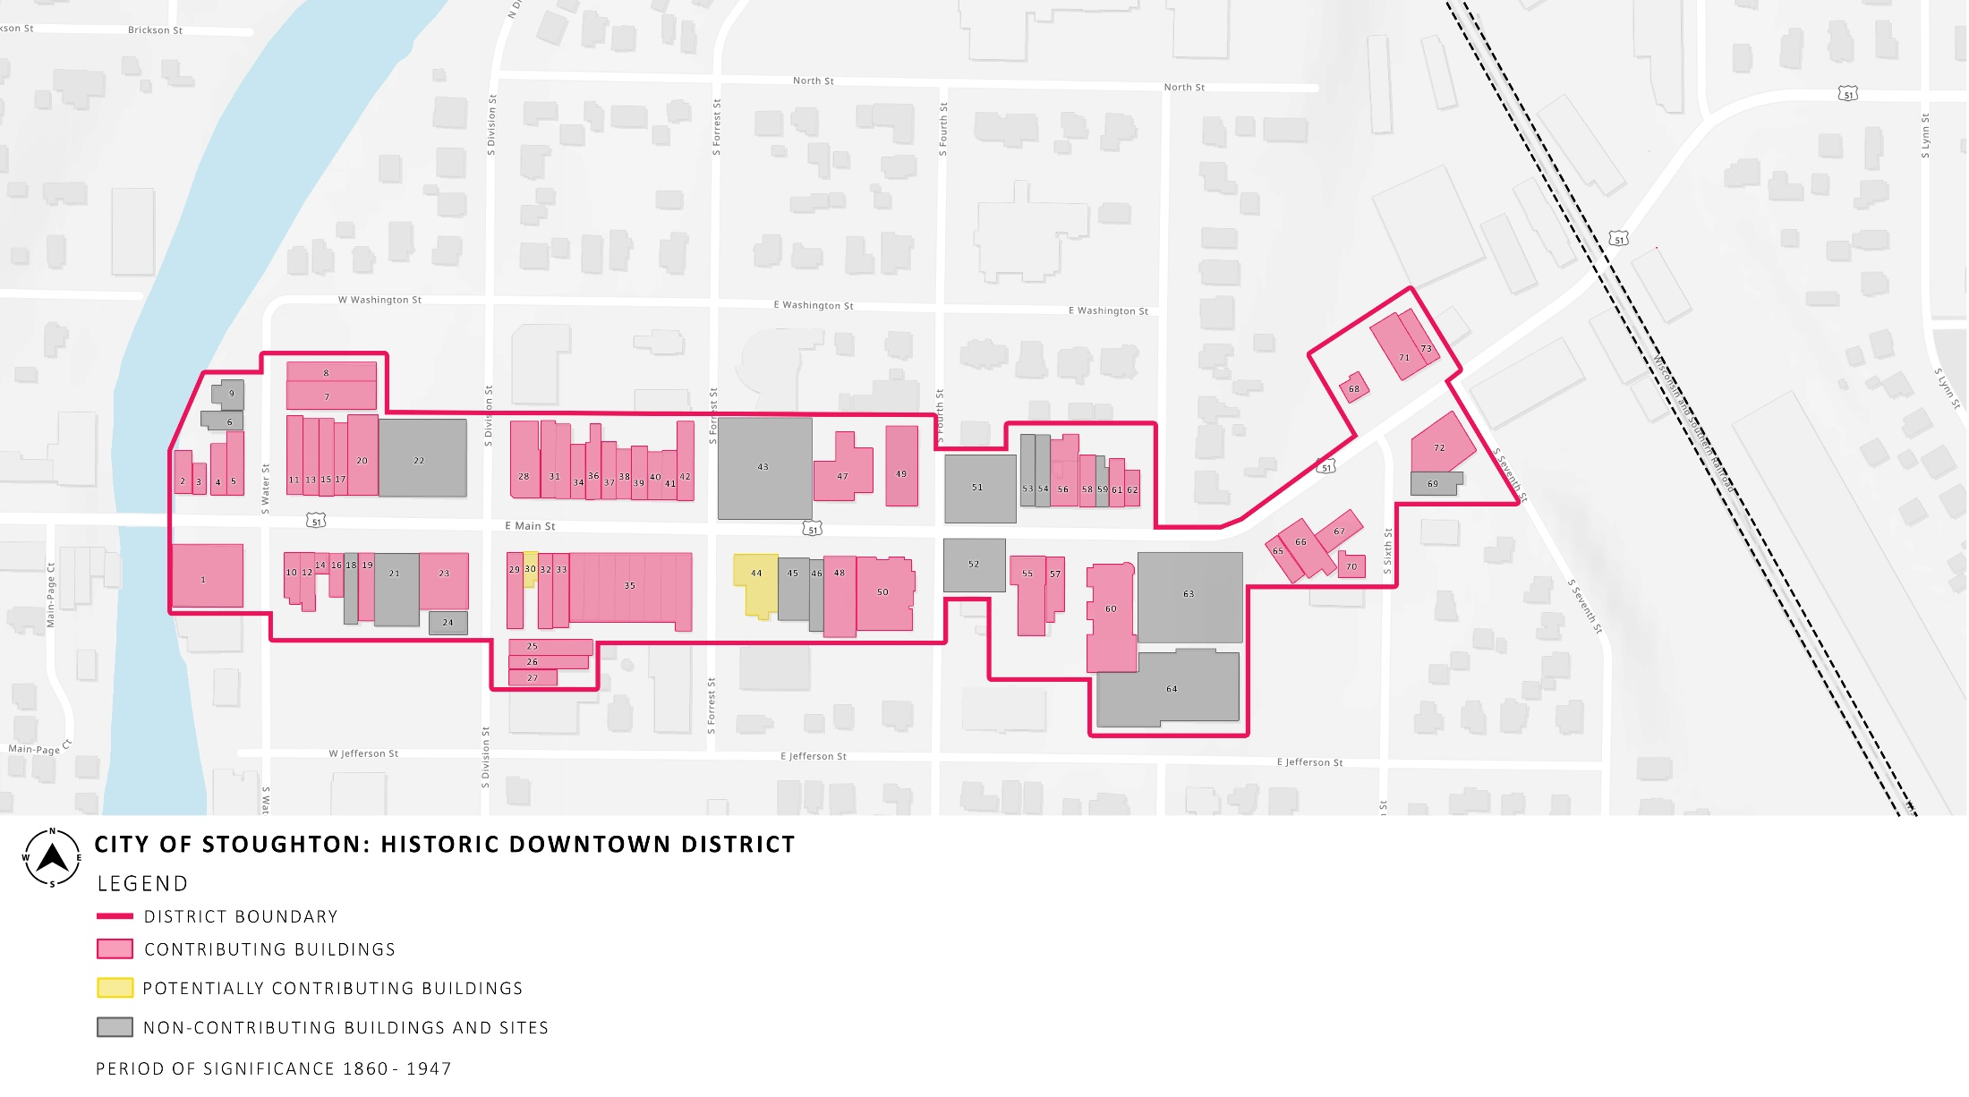

PHOTOGRAPH KEY
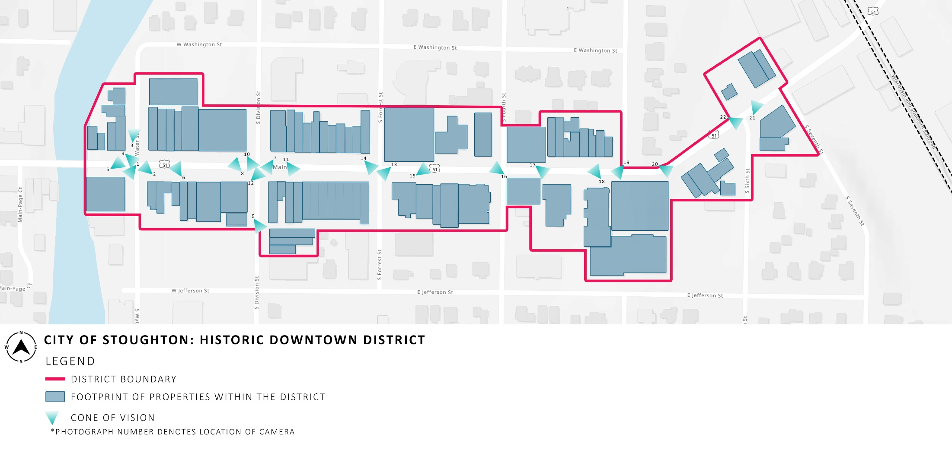

PHOTOGRAPHS
*ALL PHOTOGRAPHS TAKEN ON JULY 14, 2022.
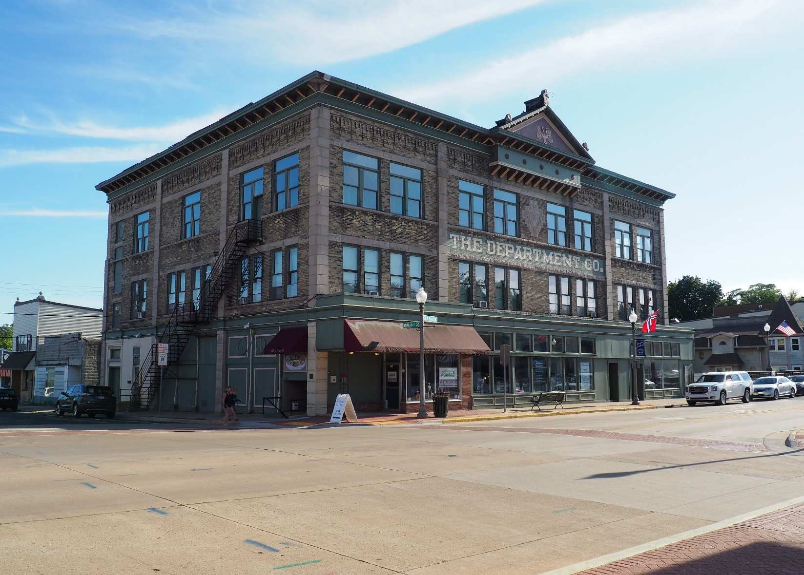PHOTOGRAPH 1 OF 22: VIEW OF THE SOUTH SIDE OF THE 200-BLOCK OF W. MAIN STREET LOOKING SOUTHWEST.
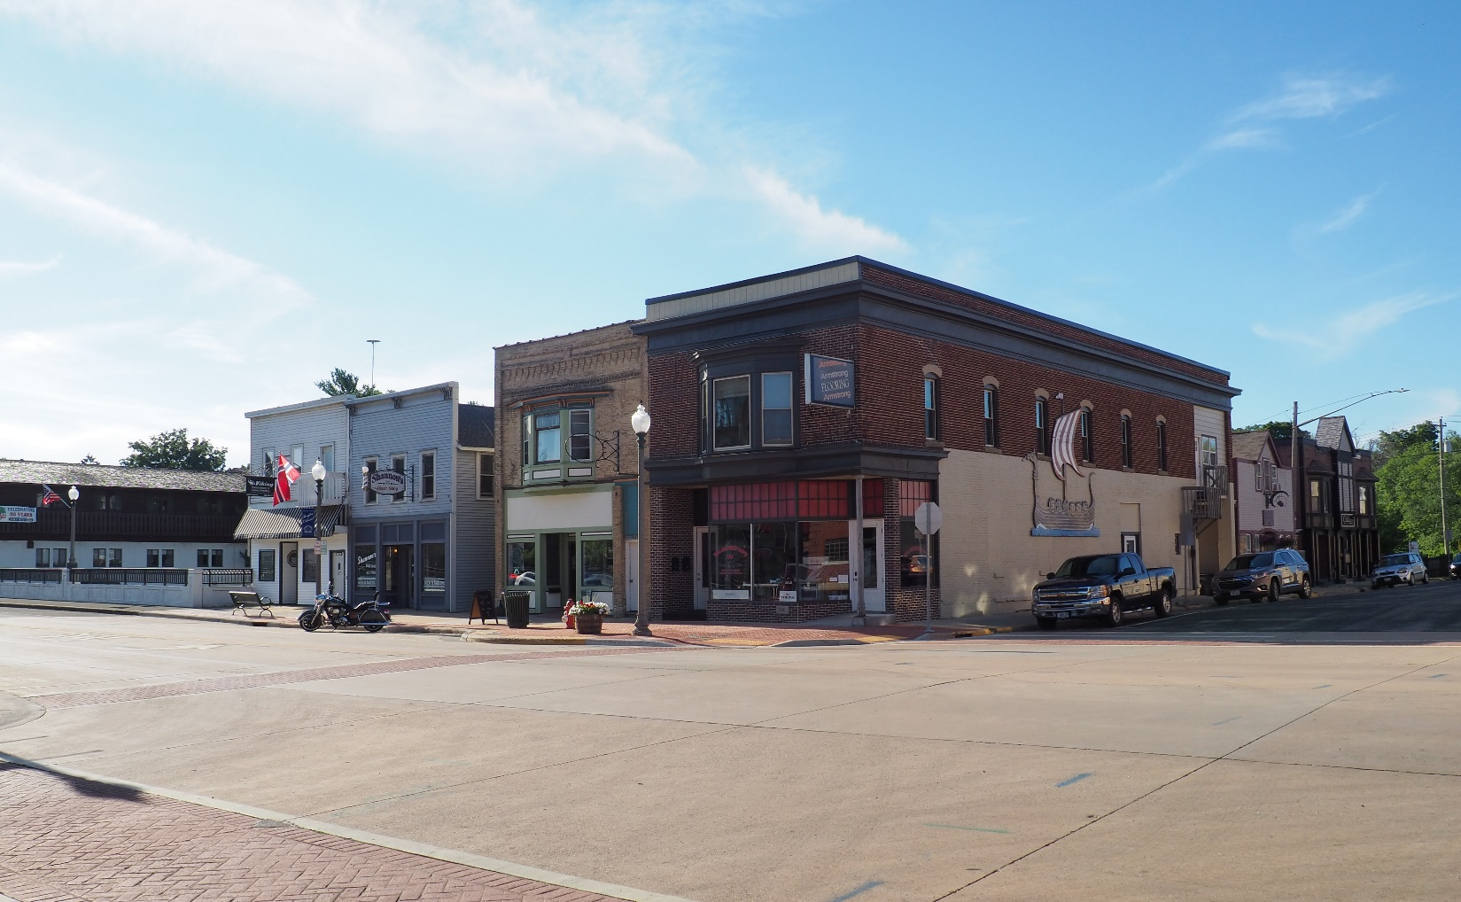
PHOTOGRAPH 2 OF 22: VIEW OF THE NORTH SIDE OF THE 200-BLOCK OF W. MAIN STREET LOOKING NORTHWEST.
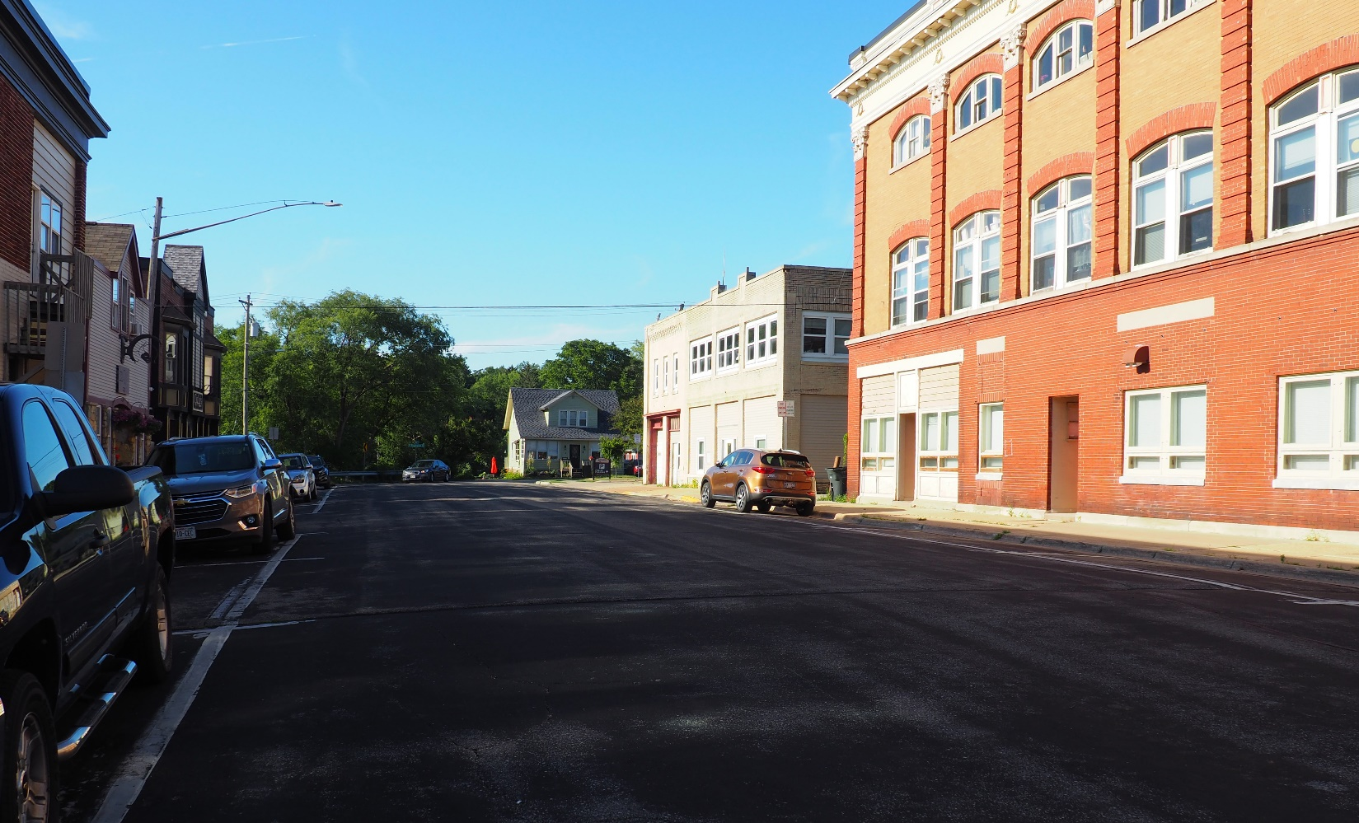
PHOTOGRAPH 3 OF 22: VIEW OF THE 200-BLOCK OF S. WATER STREET LOOKING NORTH.
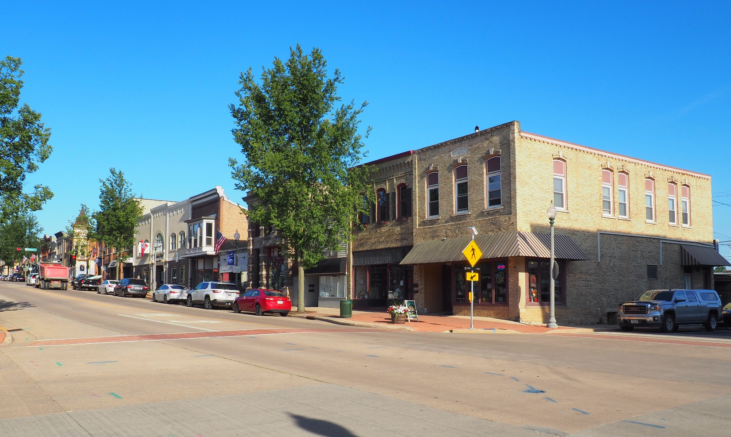 PHOTOGRAPH 4 OF 22: VIEW OF THE SOUTH SIDE OF THE 100-BLOCK OF W. MAIN STREET LOOKING SOUTHEAST.
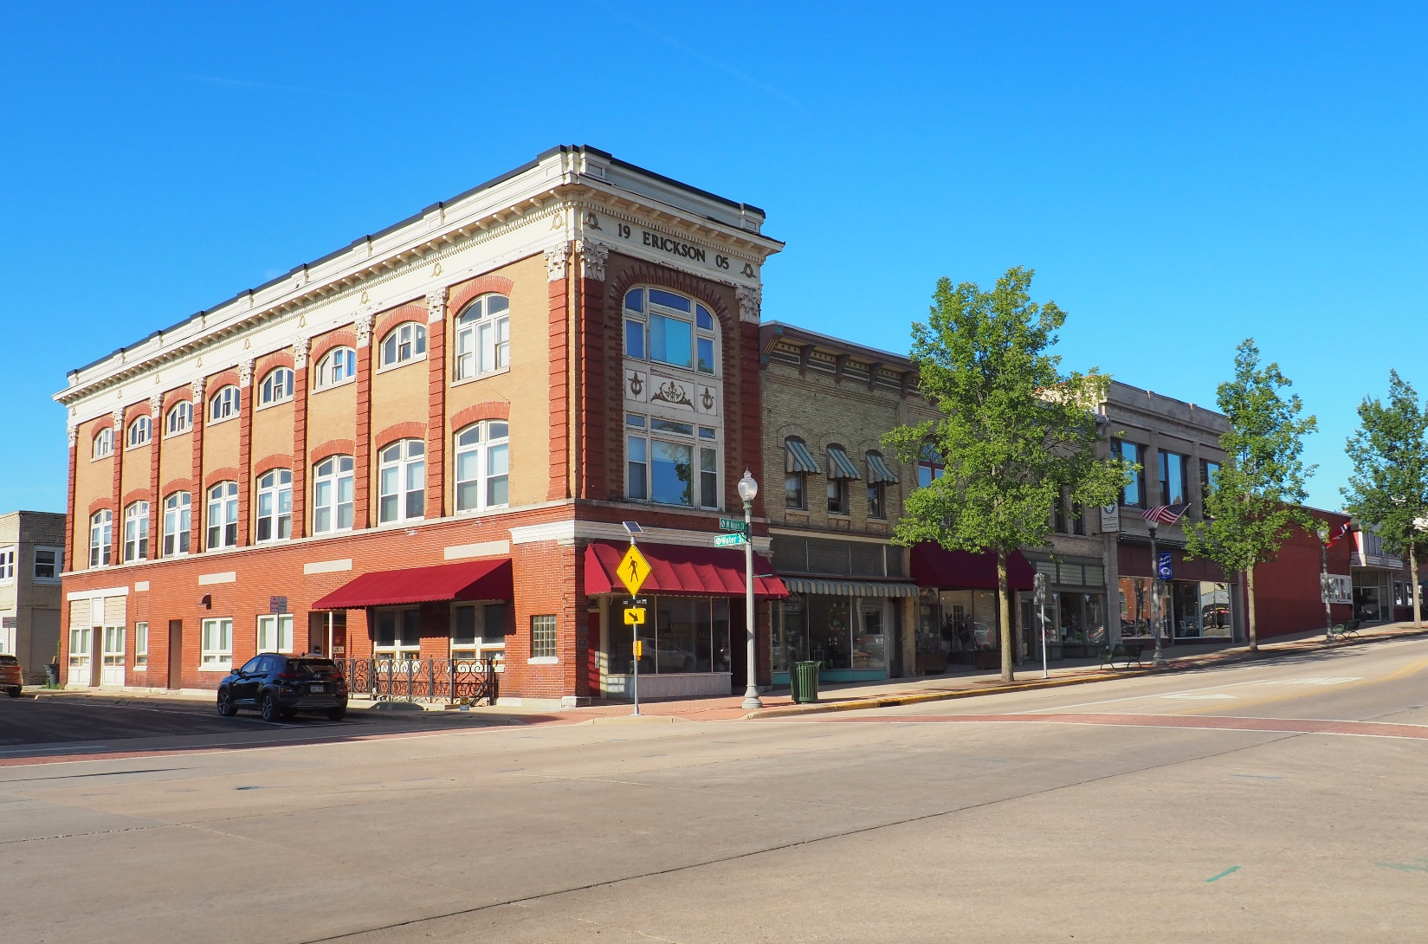
PHOTOGRAPH 5 OF 22: VIEW OF THE WEST HALF OF THE NORTH SIDE OF THE 100-BLOCK OF W. MAIN STREET LOOKING NORTHEAST.
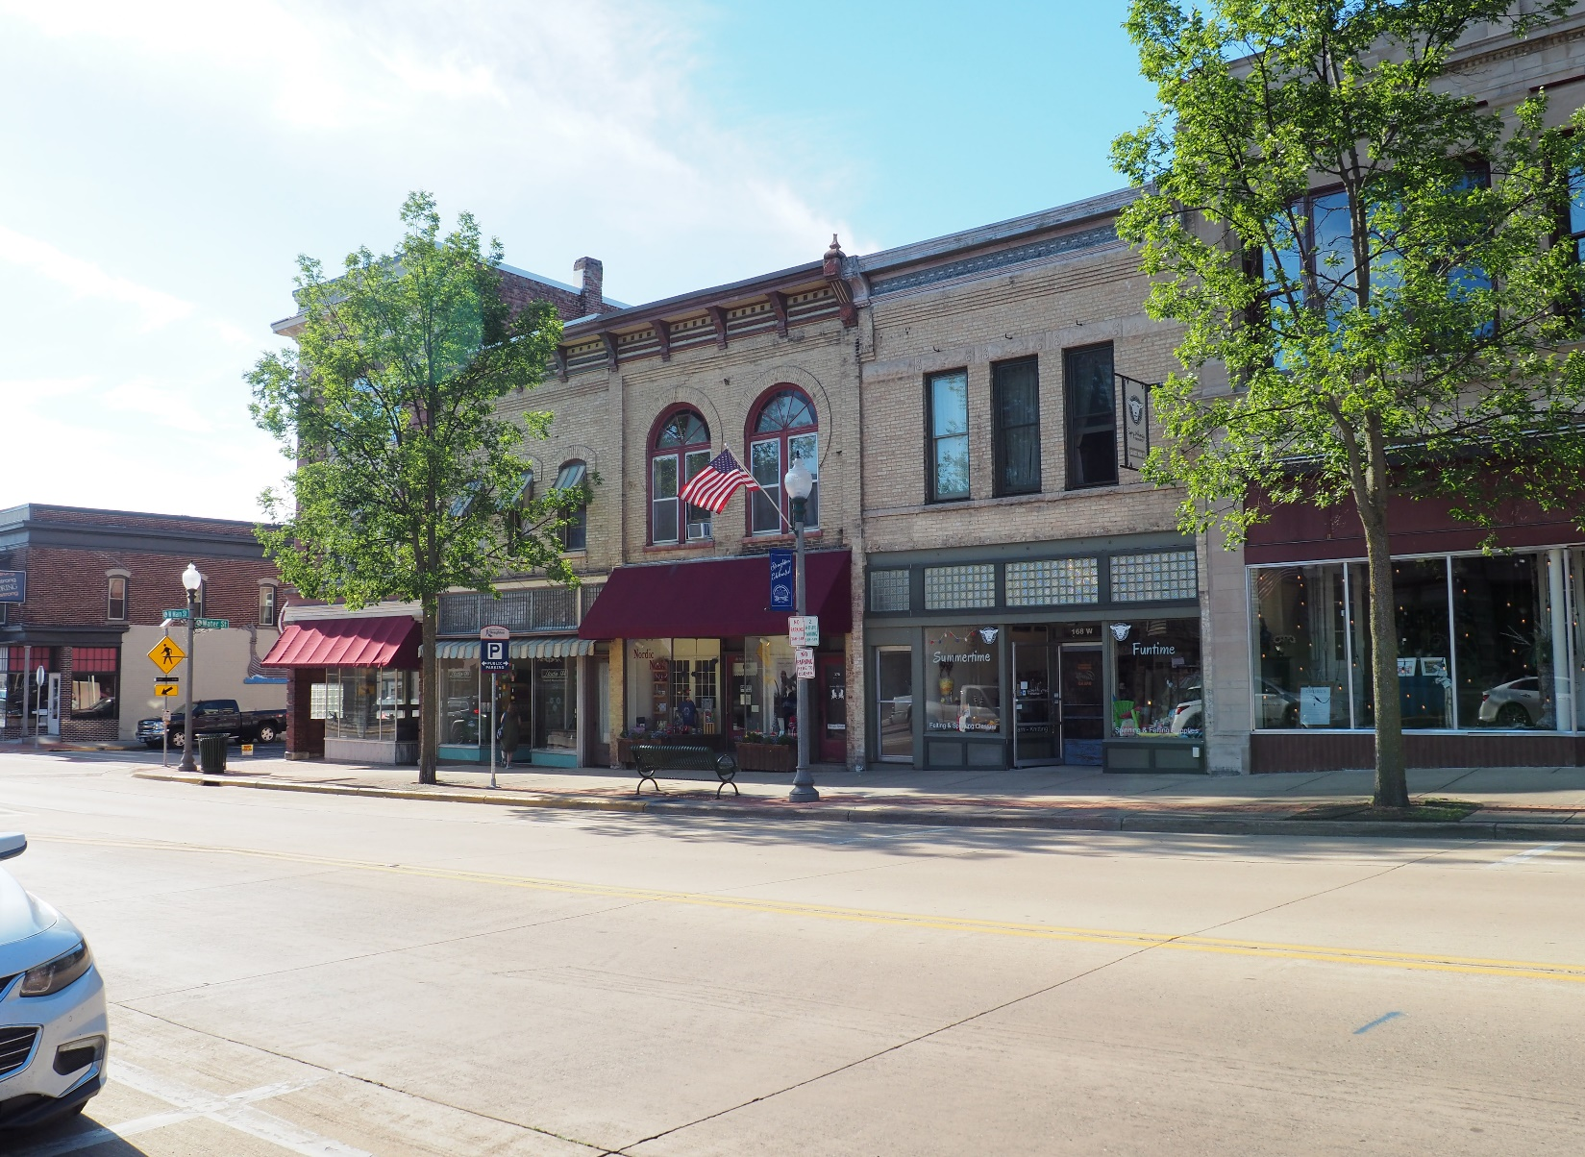
PHOTOGRAPH 6 OF 22: VIEW OF THE WEST HALF OF THE NORTH SIDE OF THE 100-BLOCK OF W. MAIN STREET LOOKING NORTHWEST.
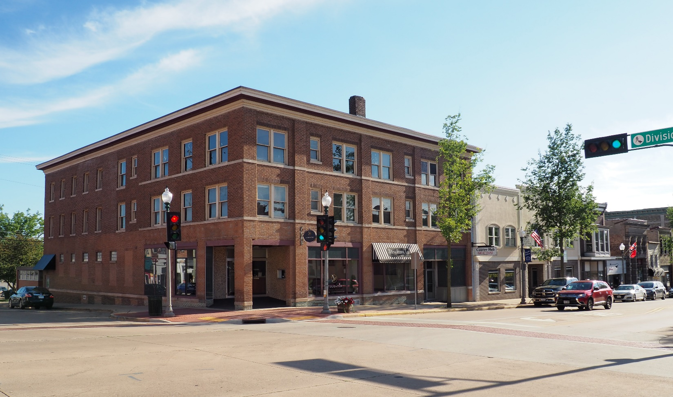
PHOTOGRAPH 7 OF 22: VIEW OF THE EAST HALF OF THE SOUTH SIDE OF THE 100-BLOCK OF W. MAIN STREET LOOKING SOUTHWEST.
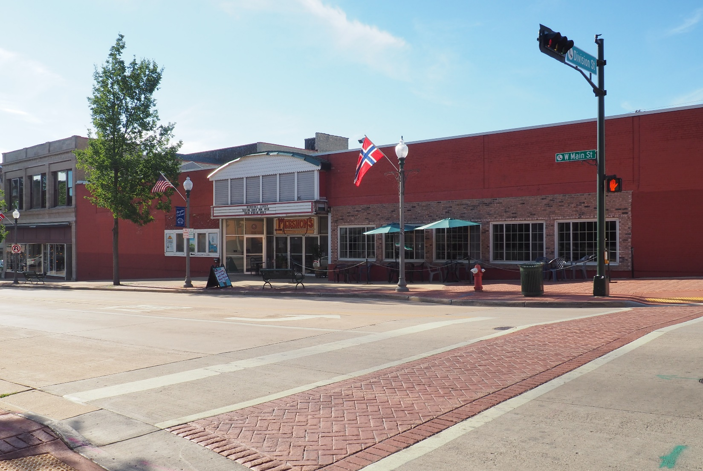
PHOTOGRAPH 8 OF 22: VIEW OF THE EAST HALF OF THE NORTH SIDE OF THE 100-BLOCK OF W. MAIN STREET LOOKING NORTHWEST.
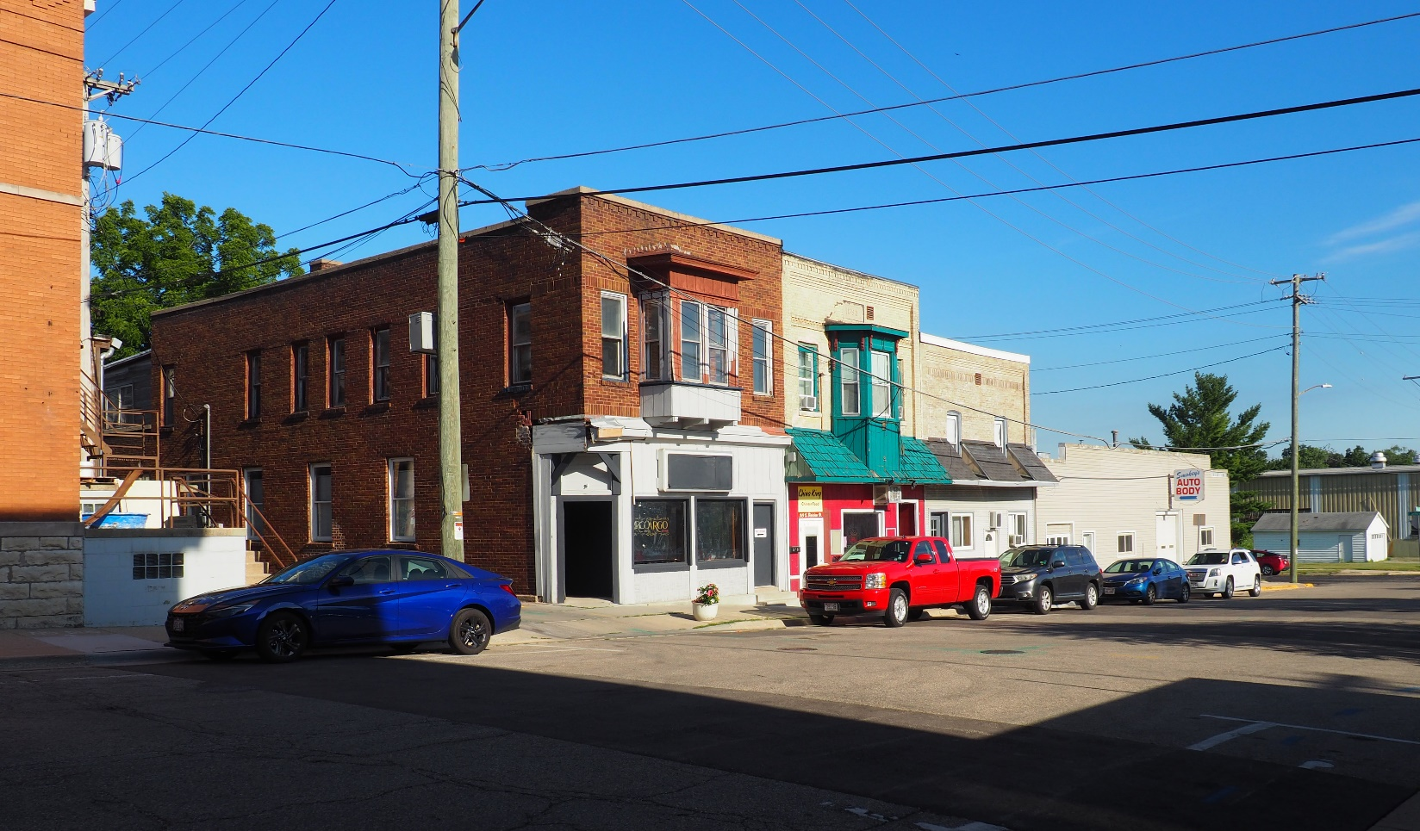 PHOTOGRAPH 9 OF 22: VIEW OF THE EAST HALF OF THE 300-BLOCK OF S. DIVISION STREET LOOKING SOUTHEAST.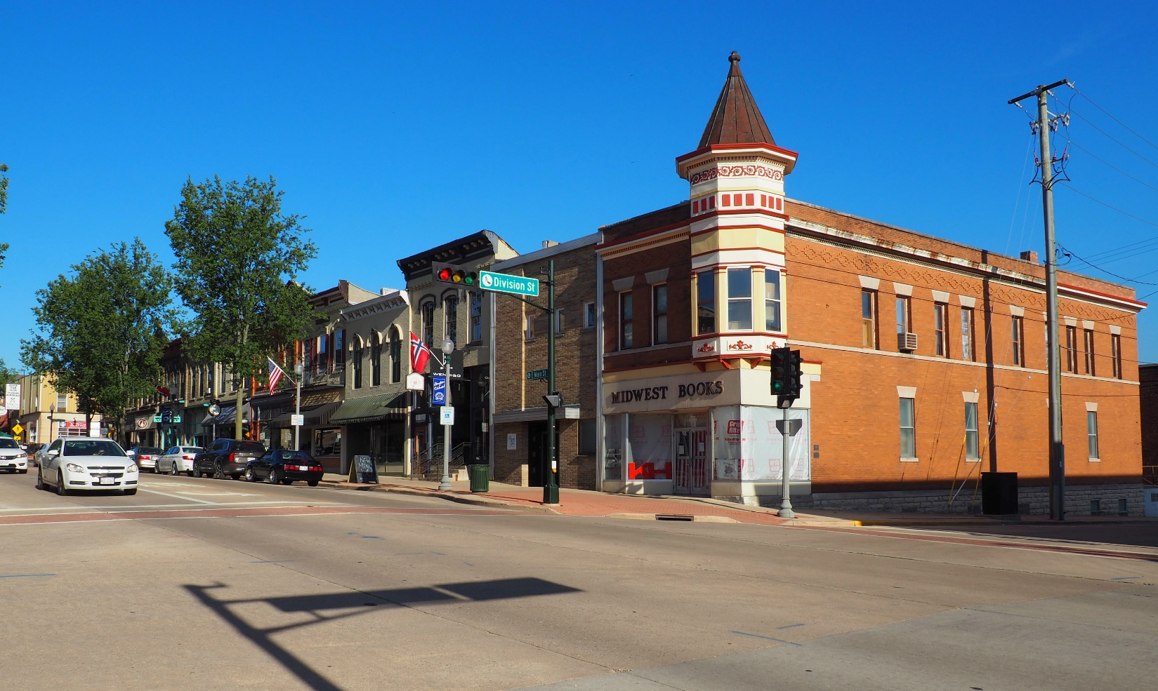 PHOTOGRAPH 10 OF 22: VIEW OF THE WEST HALF OF THE SOUTH SIDE OF THE 100-BLOCK OF E. MAIN STREET LOOKING SOUTHEAST.
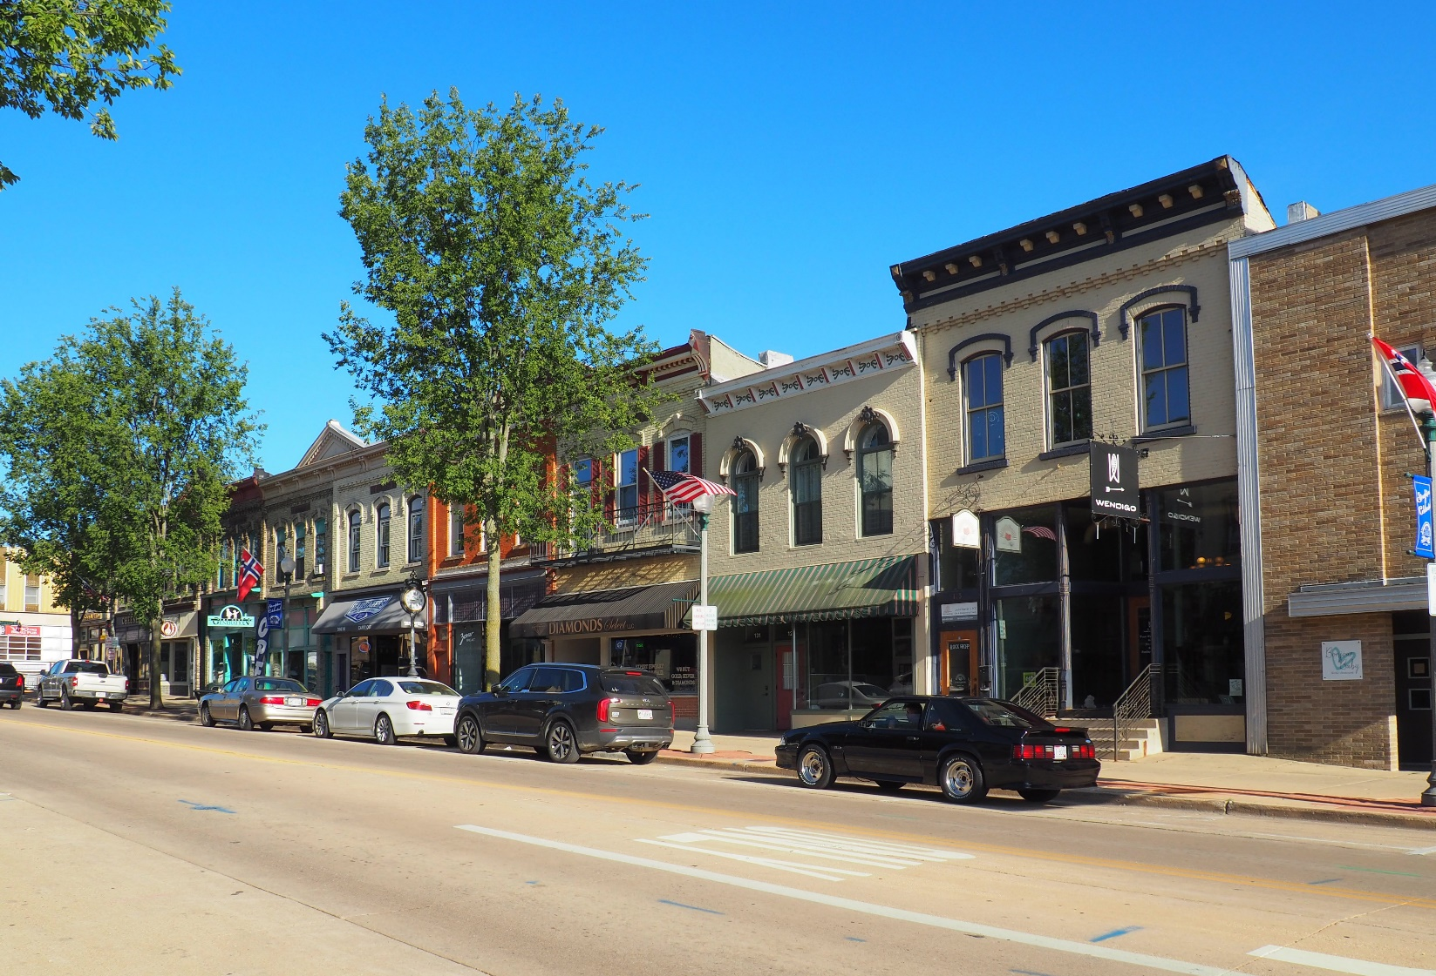
PHOTOGRAPH 11 OF 22: VIEW OF THE SOUTH SIDE OF THE 100-BLOCK OF E. MAIN STREET LOOKING SOUTHEAST.
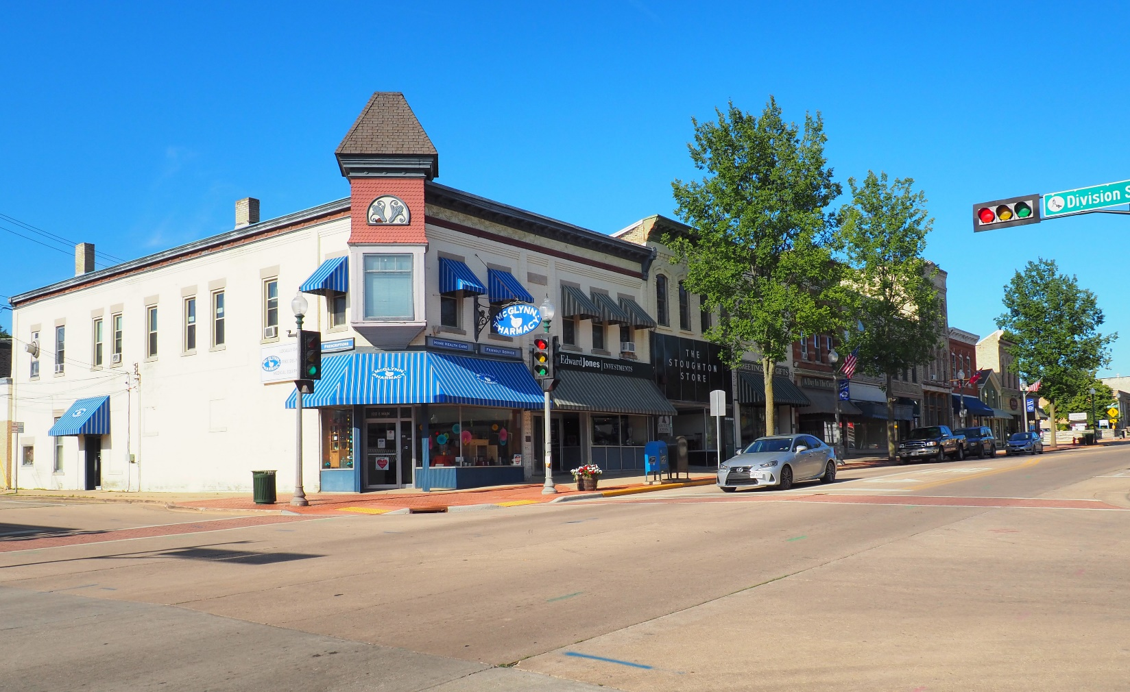
PHOTOGRAPH 12 OF 22: VIEW OF THE NORTH SIDE OF THE 100-BLOCK OF E. MAIN STREET LOOKING NORTHEAST.
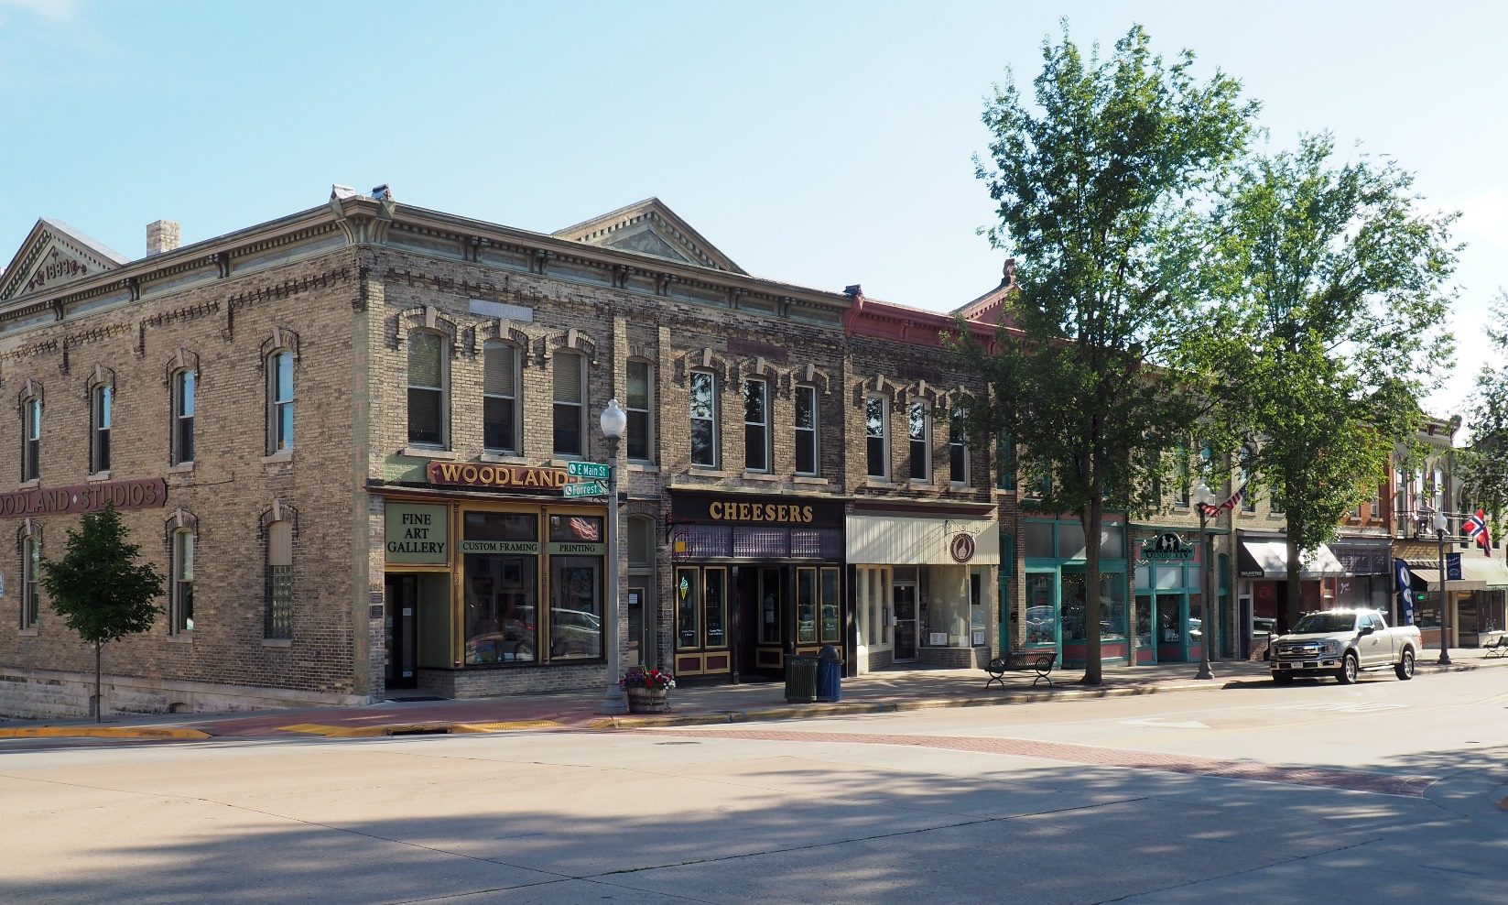 PHOTOGRAPH 13 OF 22: VIEW OF THE EAST HALF OF THE SOUTH SIDE OF THE 100-BLOCK OF E. MAIN STREET LOOKING SOUTHWEST.
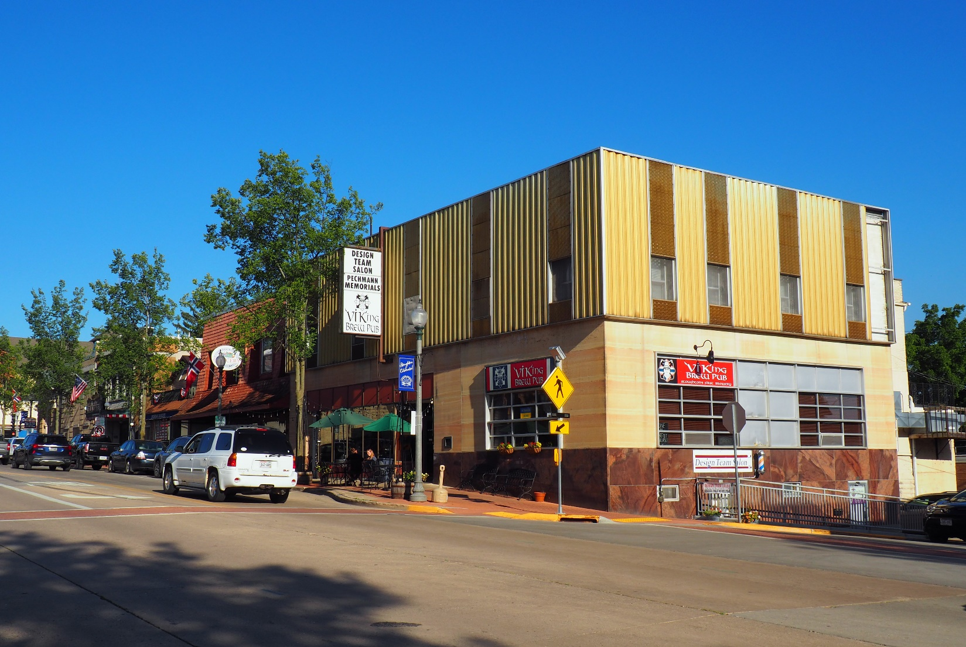 PHOTOGRAPH 14 OF 22: VIEW OF THE WEST HALF OF THE SOUTH SIDE OF THE 200-BLOCK OF E. MAIN STREET LOOKING SOUTHEAST.

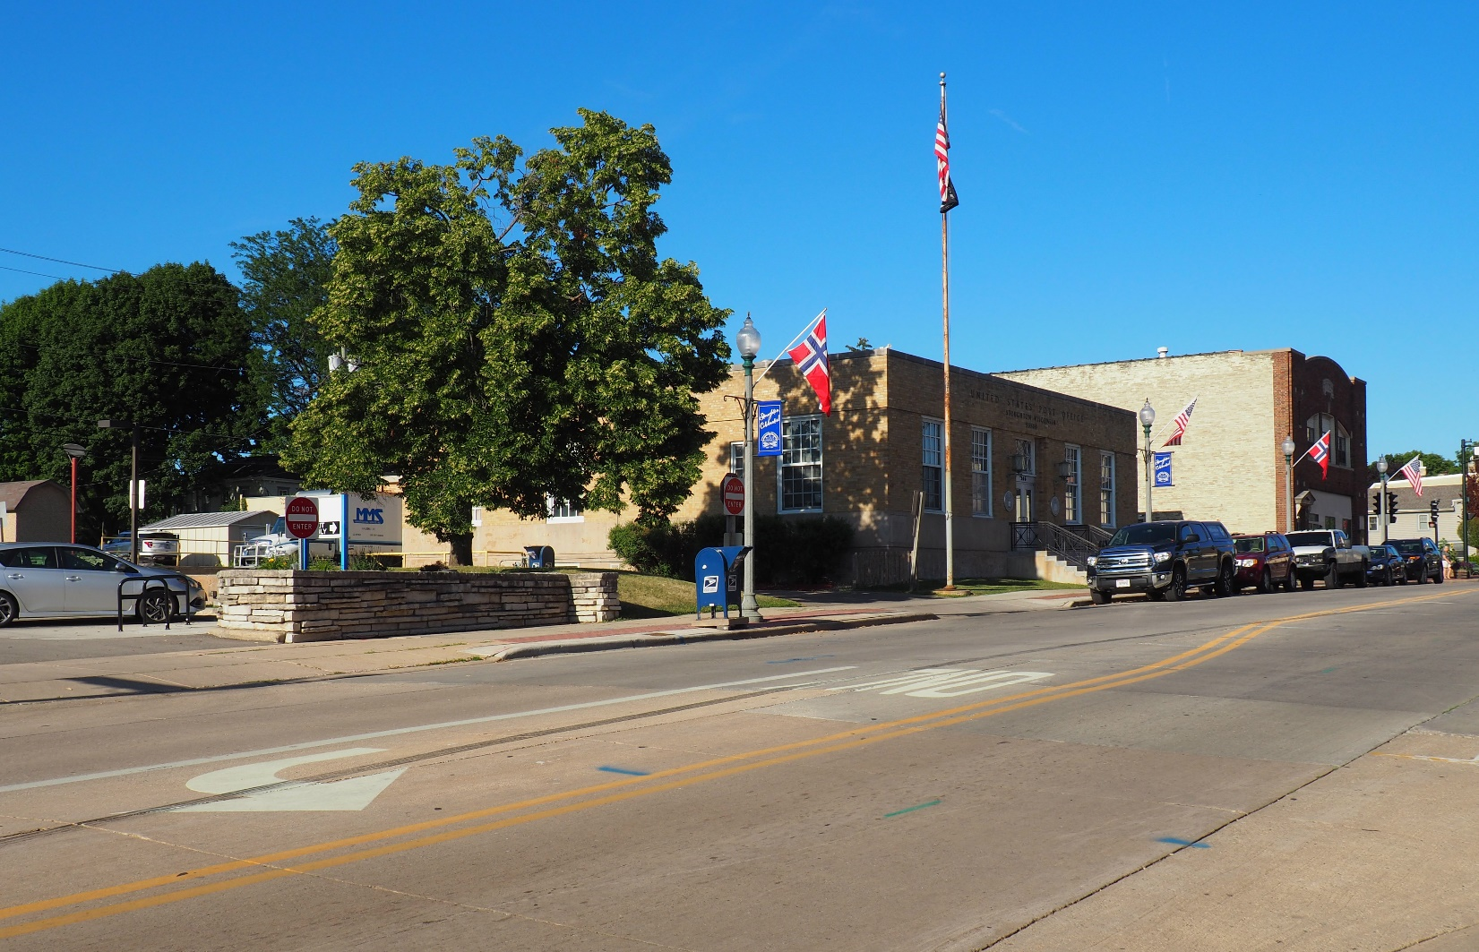 PHOTOGRAPH 15 OF 22: VIEW OF THE NORTH SIDE OF THE 200-BLOCK OF E. MAIN STREET LOOKING NORTHEAST.
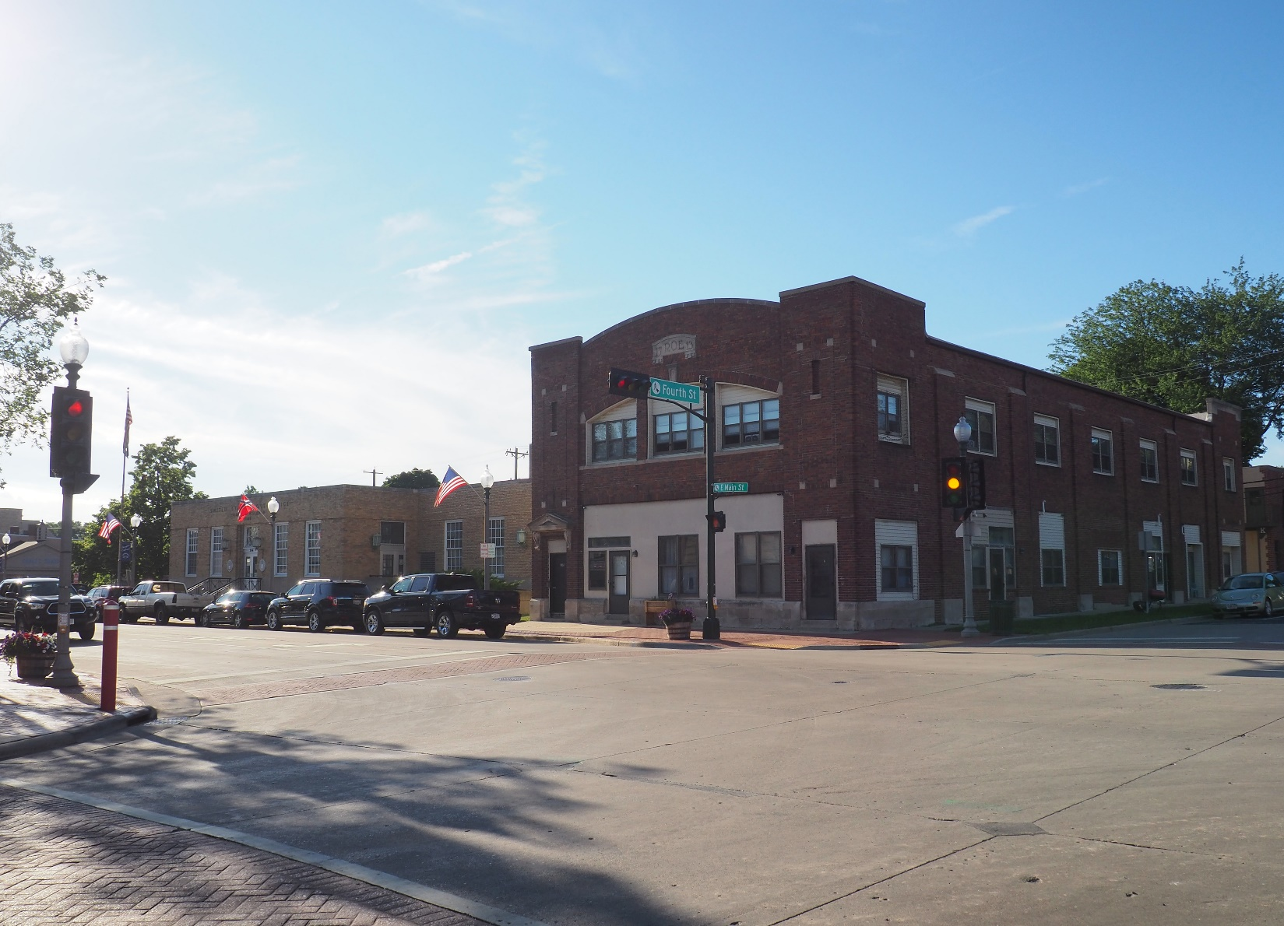 PHOTOGRAPH 16 OF 22: VIEW OF THE NORTH SIDE OF THE 200-BLOCK OF E. MAIN STREET LOOKING NORTHWEST.
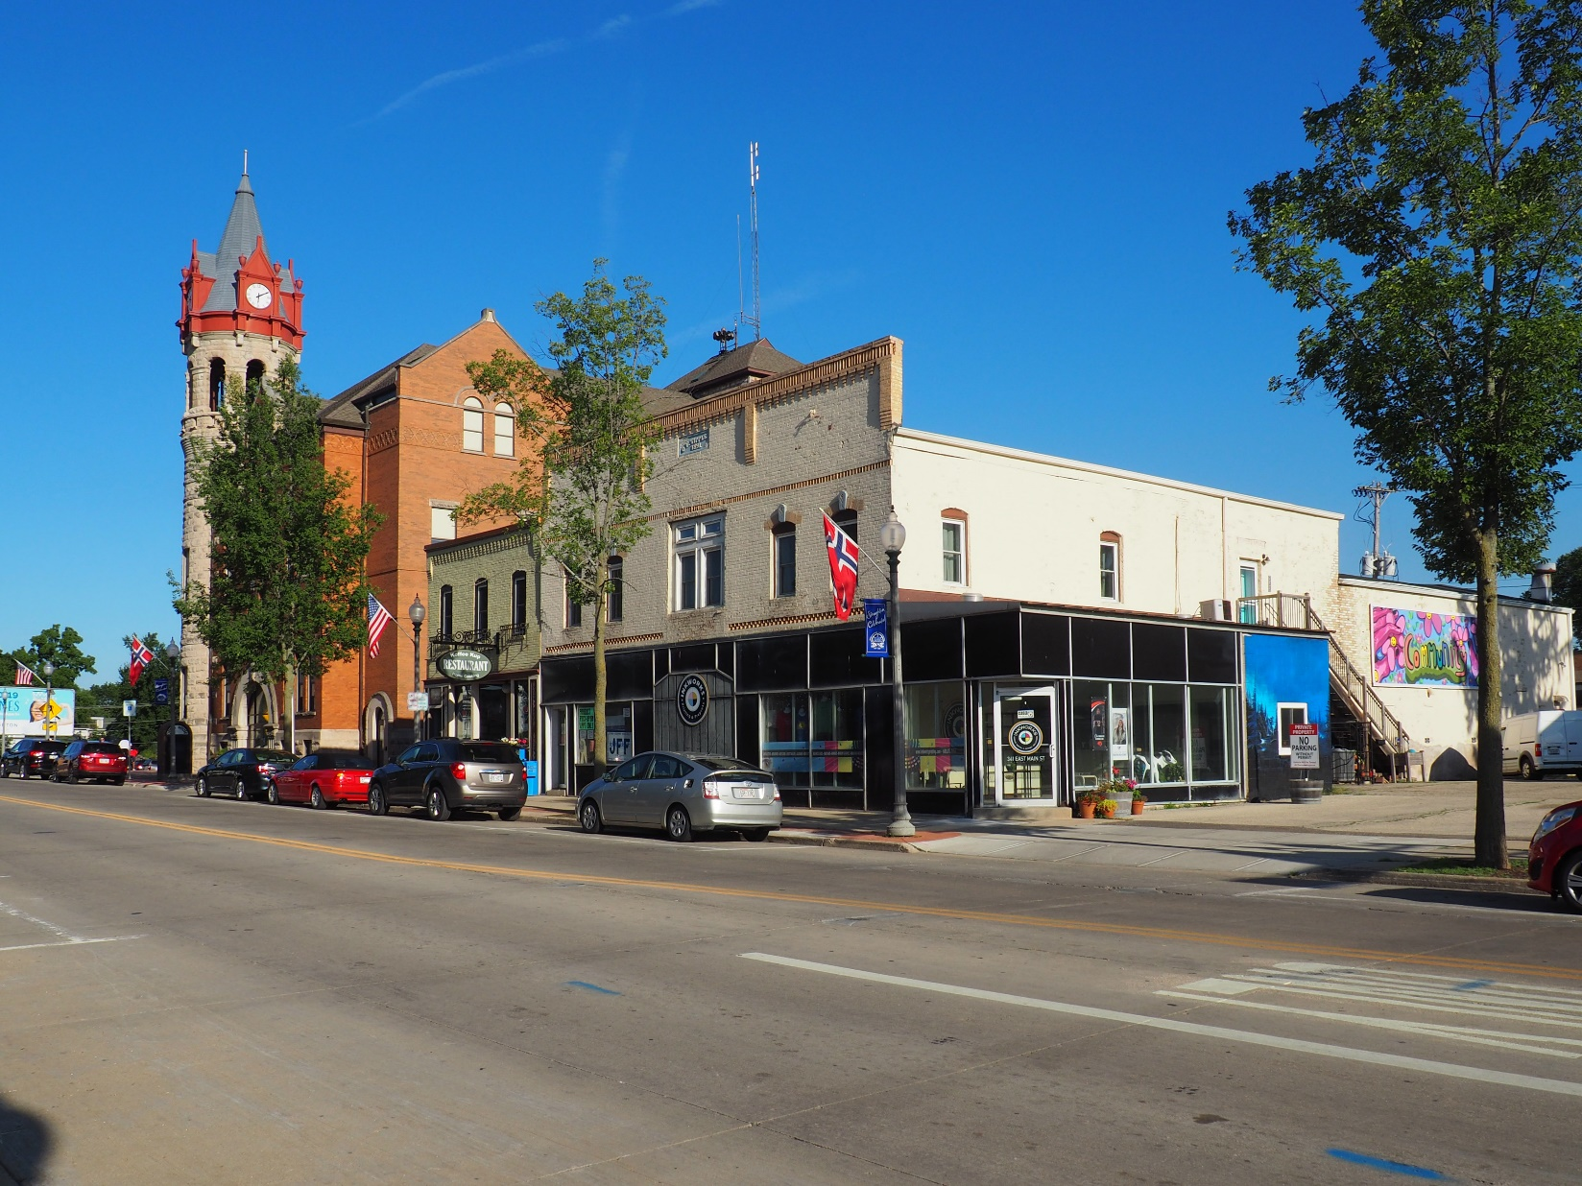 PHOTOGRAPH 17 OF 22: VIEW OF THE SOUTH SIDE OF THE 300-BLOCK OF E. MAIN STREET LOOKING SOUTHEAST. 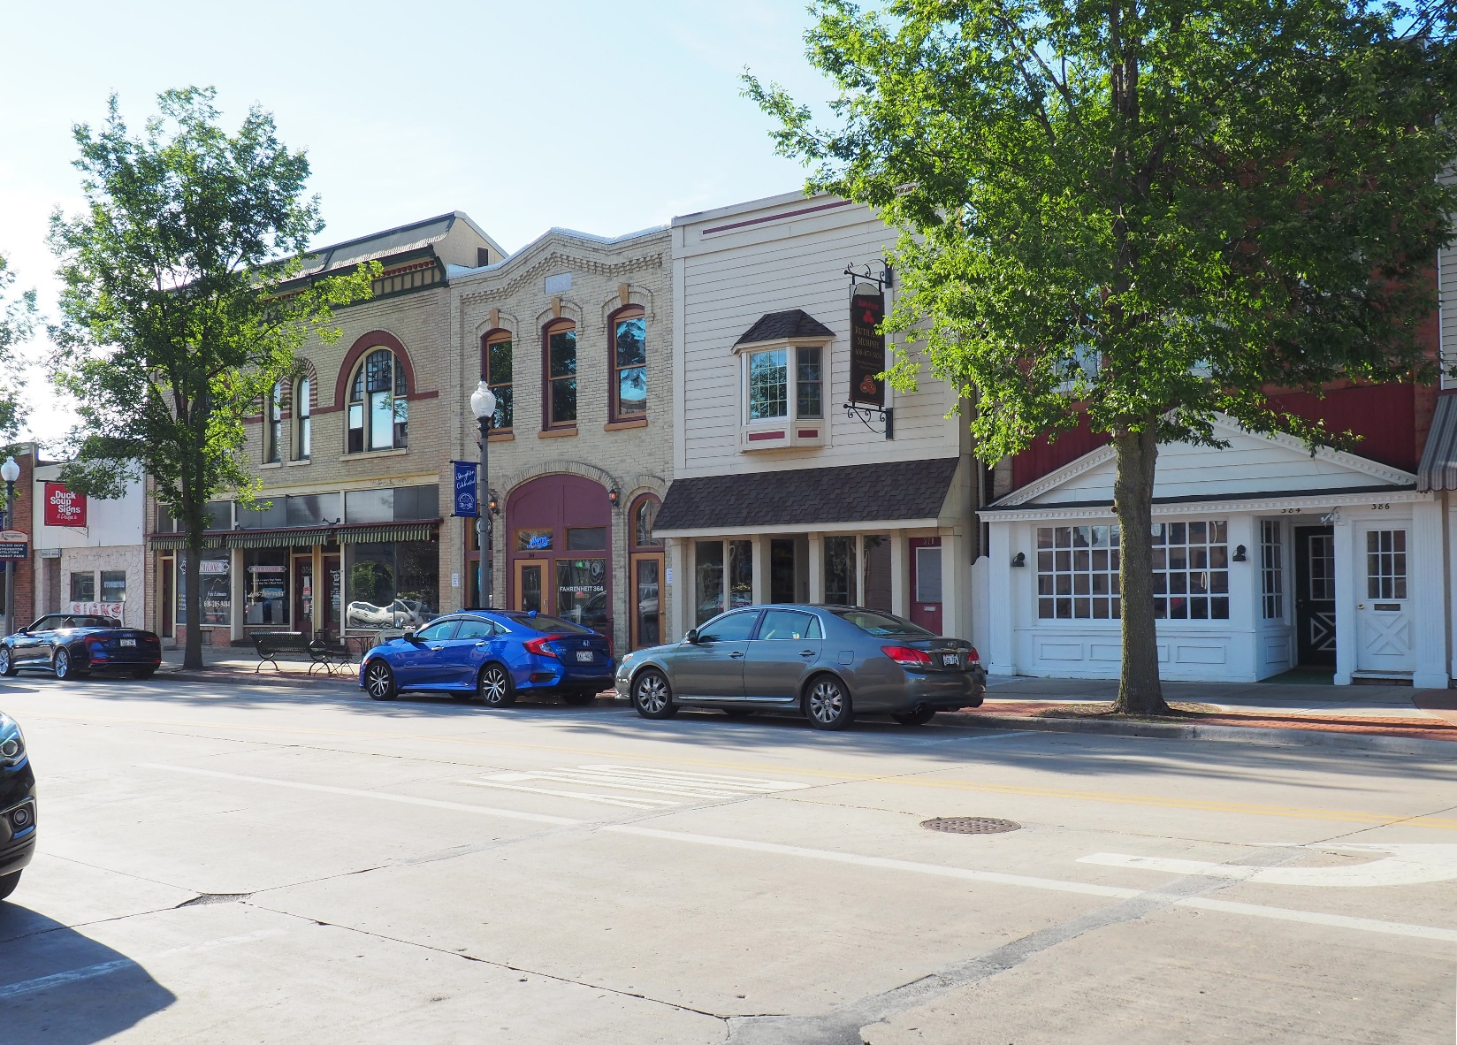
PHOTOGRAPH 18 OF 22: VIEW OF THE CENTER OF THE NORTH SIDE OF THE 300-BLOCK OF E. MAIN STREET LOOKING NORTHWEST.
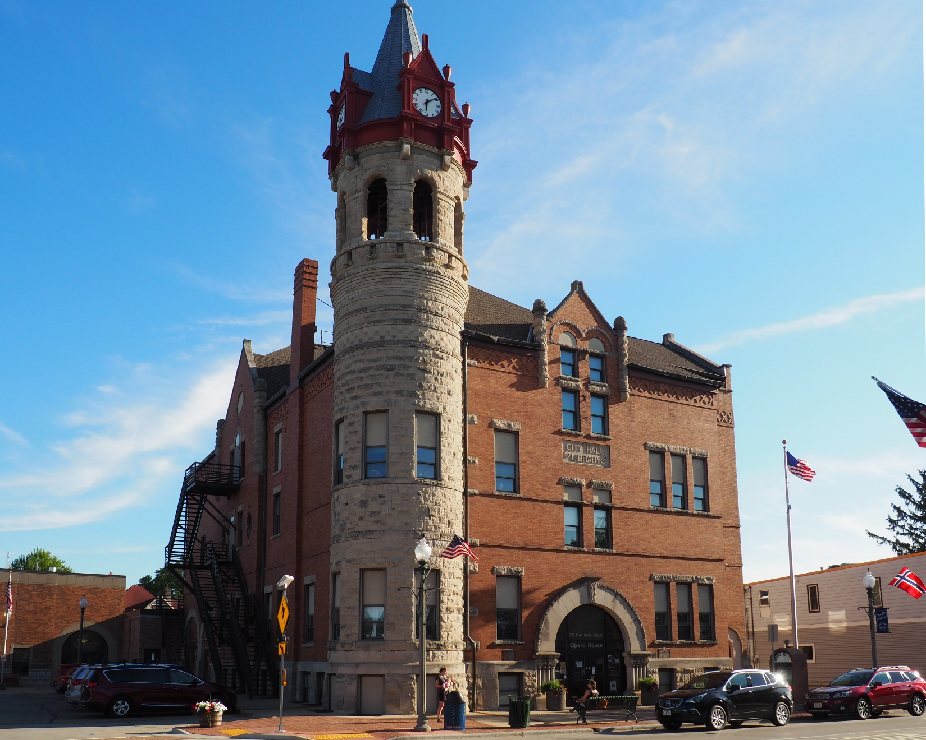 PHOTOGRAPH 19 OF 22: VIEW OF THE STOUGHTON OPERA HOUSE AT 381 E. MAIN STREET LOOKING SOUTHWEST.
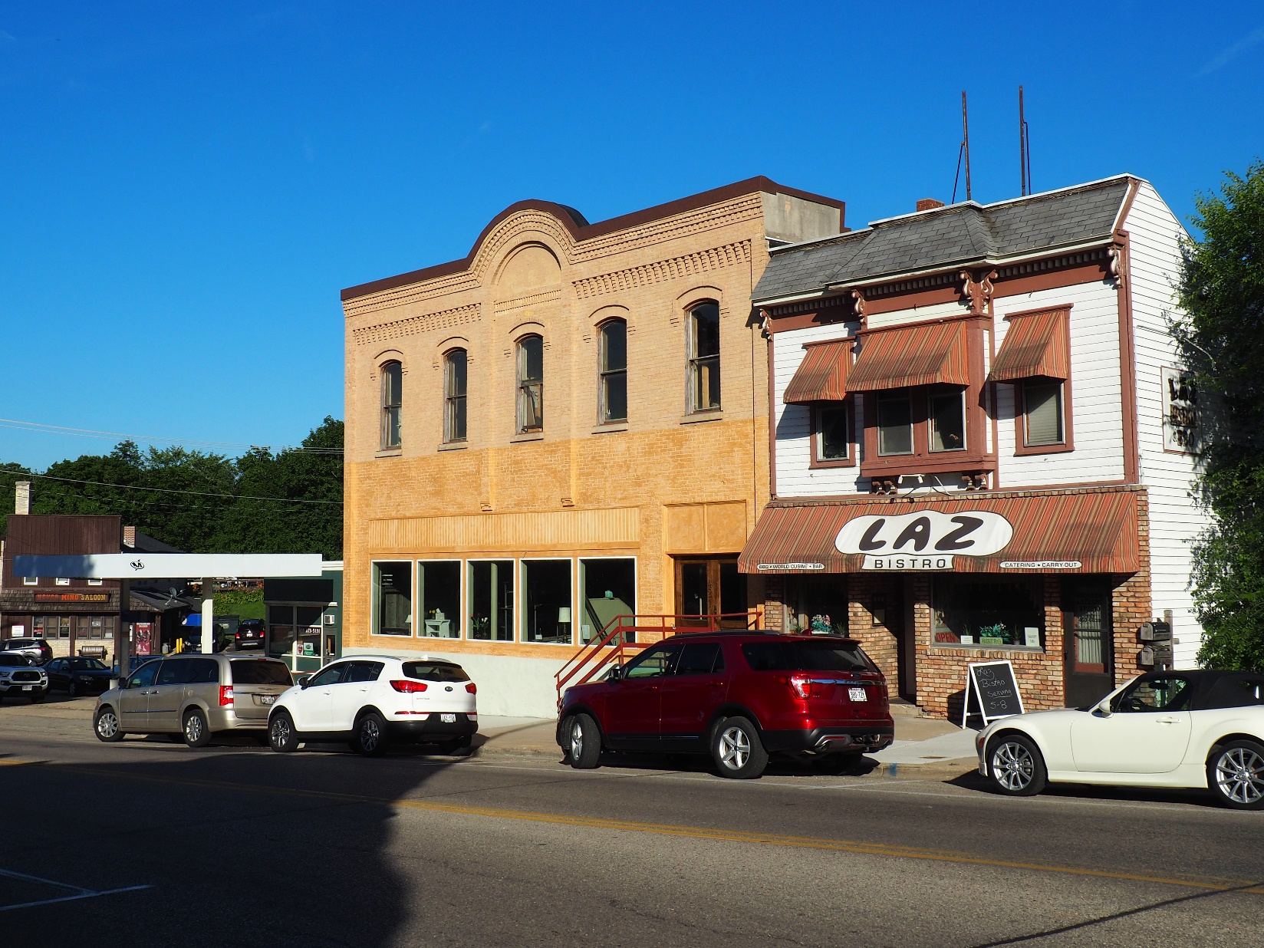 PHOTOGRAPH 20 OF 22: VIEW OF THE SOUTH SIDE OF THE 400-BLOCK OF E. MAIN STREET LOOKING SOUTHEAST. 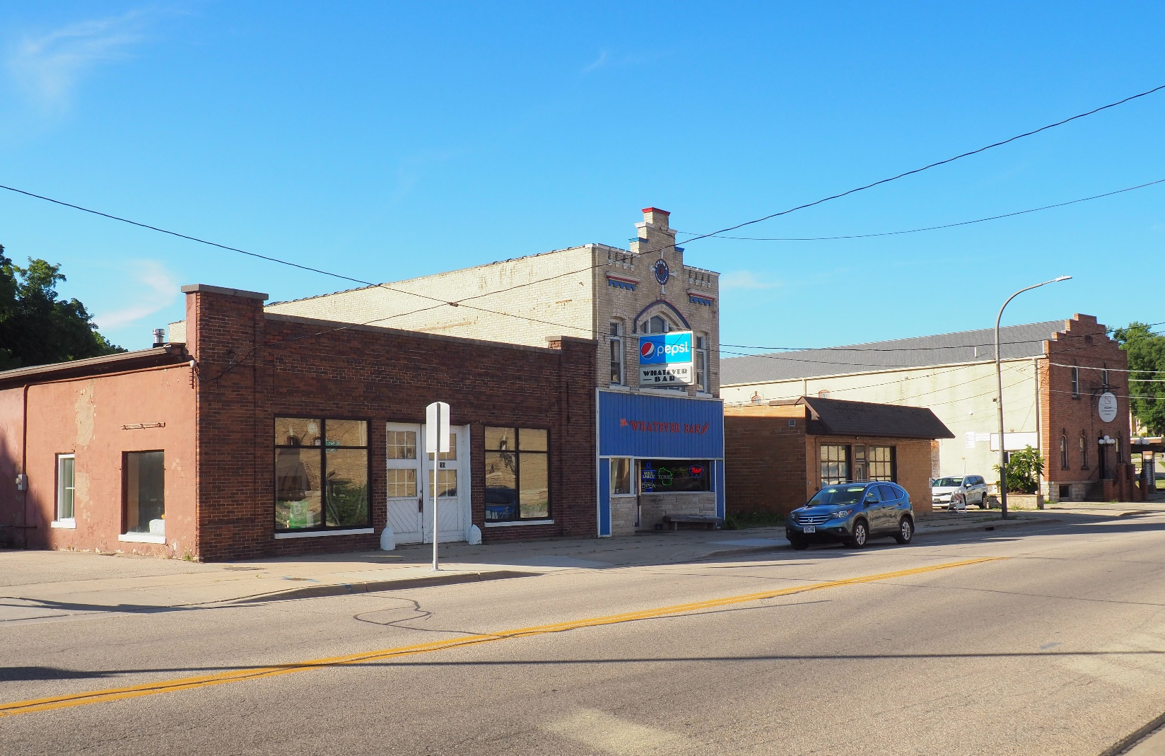 PHOTOGRAPH 21 OF 22: VIEW OF THE NORTH SIDE OF THE 500-BLOCK OF E. MAIN STREET LOOKING NORTHEAST. 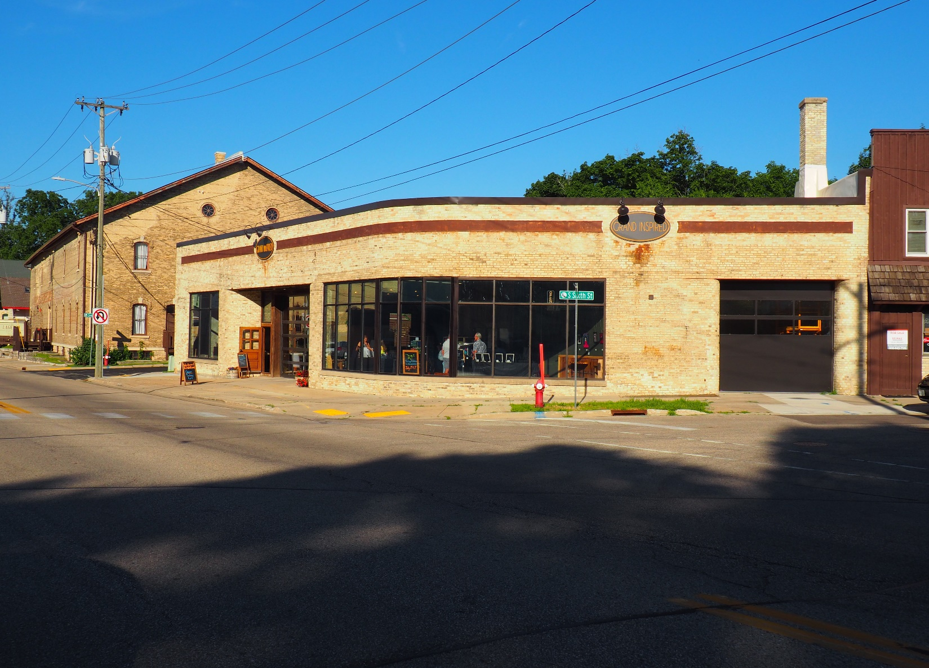 PHOTOGRAPH 22 OF 22: VIEW OF THE DOUGHBOY FEEDS BUILDING AT 501 E. MAIN STREET LOOKING SOUTHEAST.

HISTORIC PHOTOGRAPHS
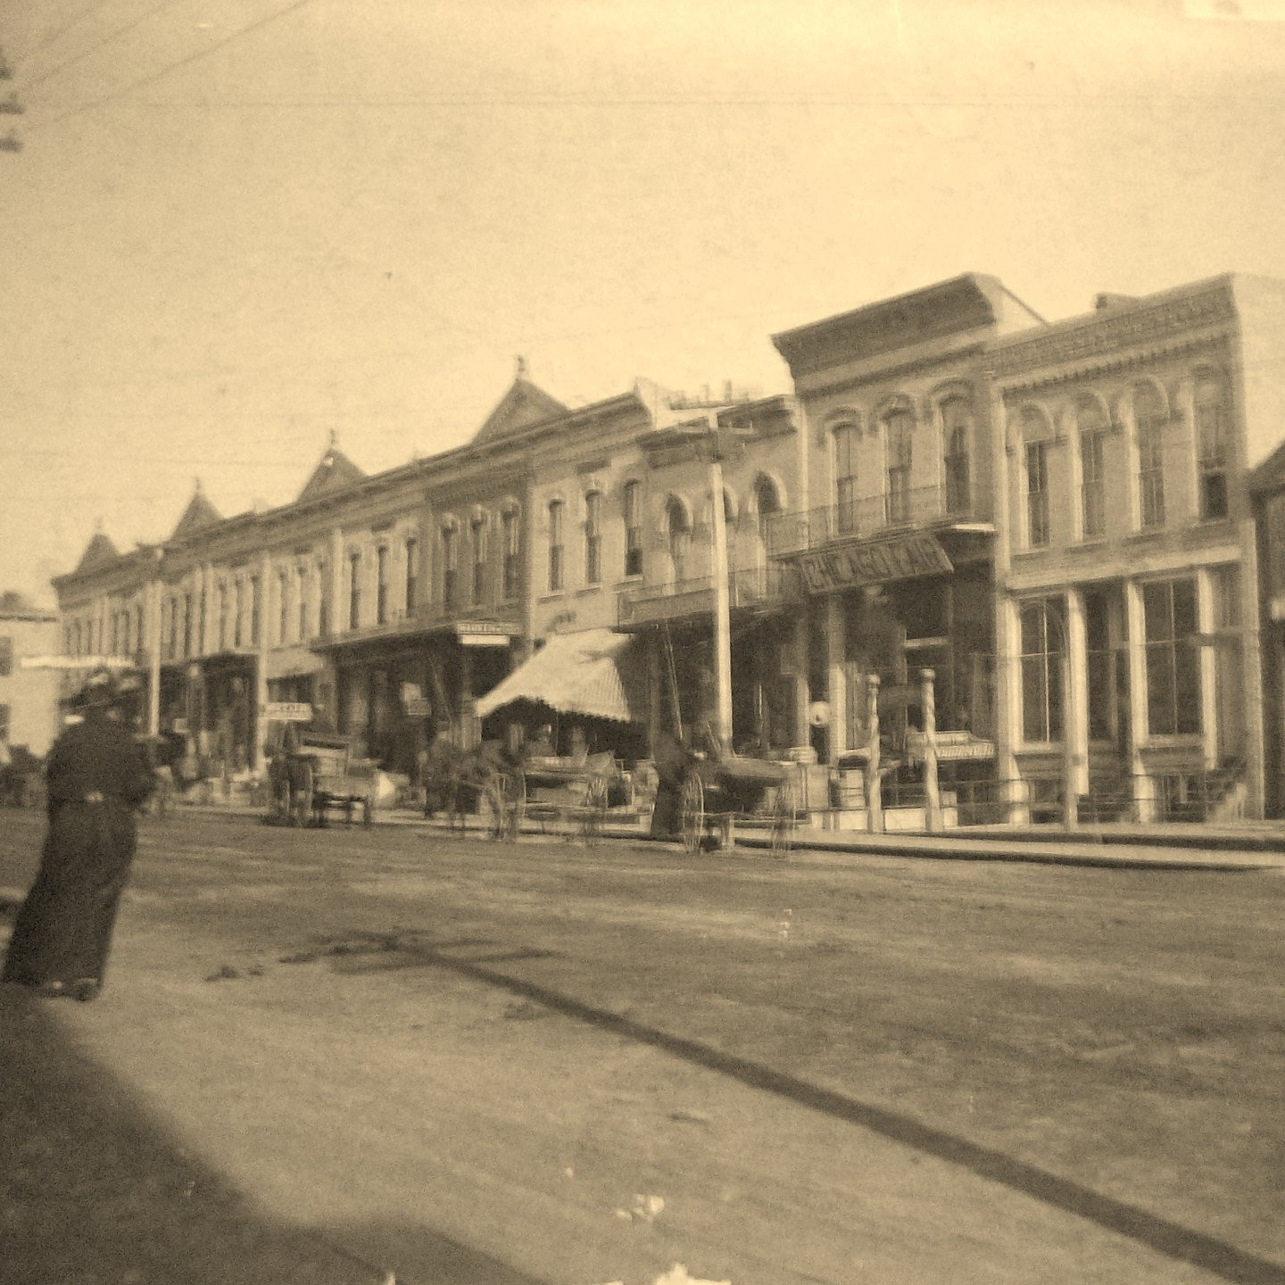
HISTORIC PHOTOGRAPH 1 OF 21: VIEW OF THE SOUTH SIDE OF THE 100-BLOCK OF E. MAIN STREET, UNDATED. COURTESY OF THE STOUGHTON HISTORICAL SOCIETY.
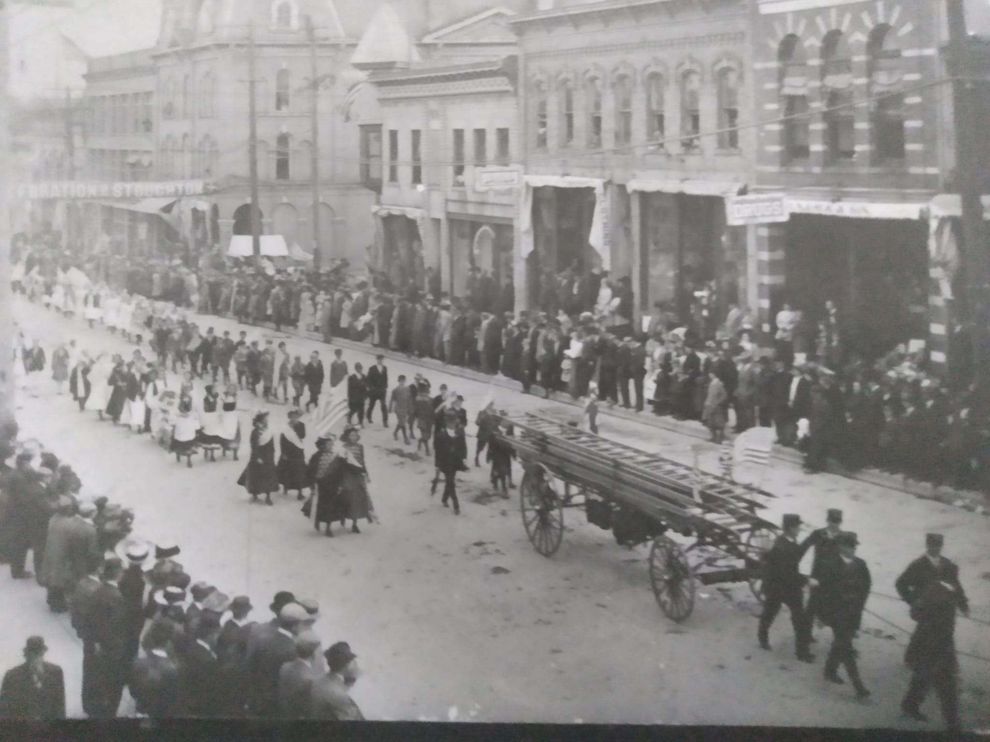 HISTORIC PHOTOGRAPH 2 OF 21: VIEW OF THE NORTH SIDE OF THE 100-BLOCK OF E. MAIN STREET. COURTESY OF THE STOUGHTON HISTORICAL SOCIETY.
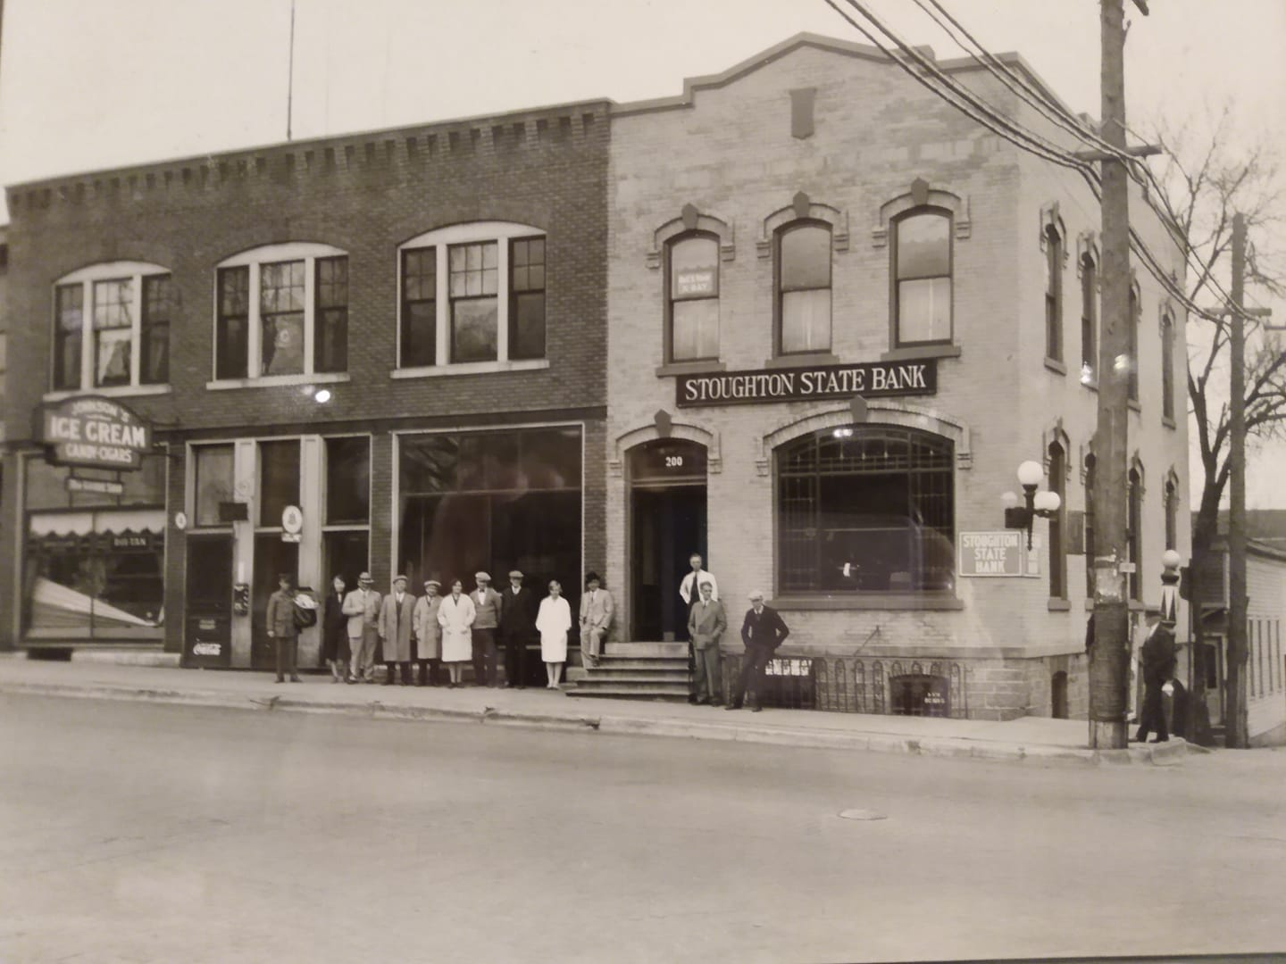 HISTORIC PHOTOGRAPH 3 OF 21: VIEW OF 211 E. MAIN STREET BEFORE THE INSTALLATION OF THE EXISTING SLIPCOVER AND STOREFRONT REMODELING, UNDATED. COURTESY OF THE STOUGHTON HISTORICAL SOCIETY.
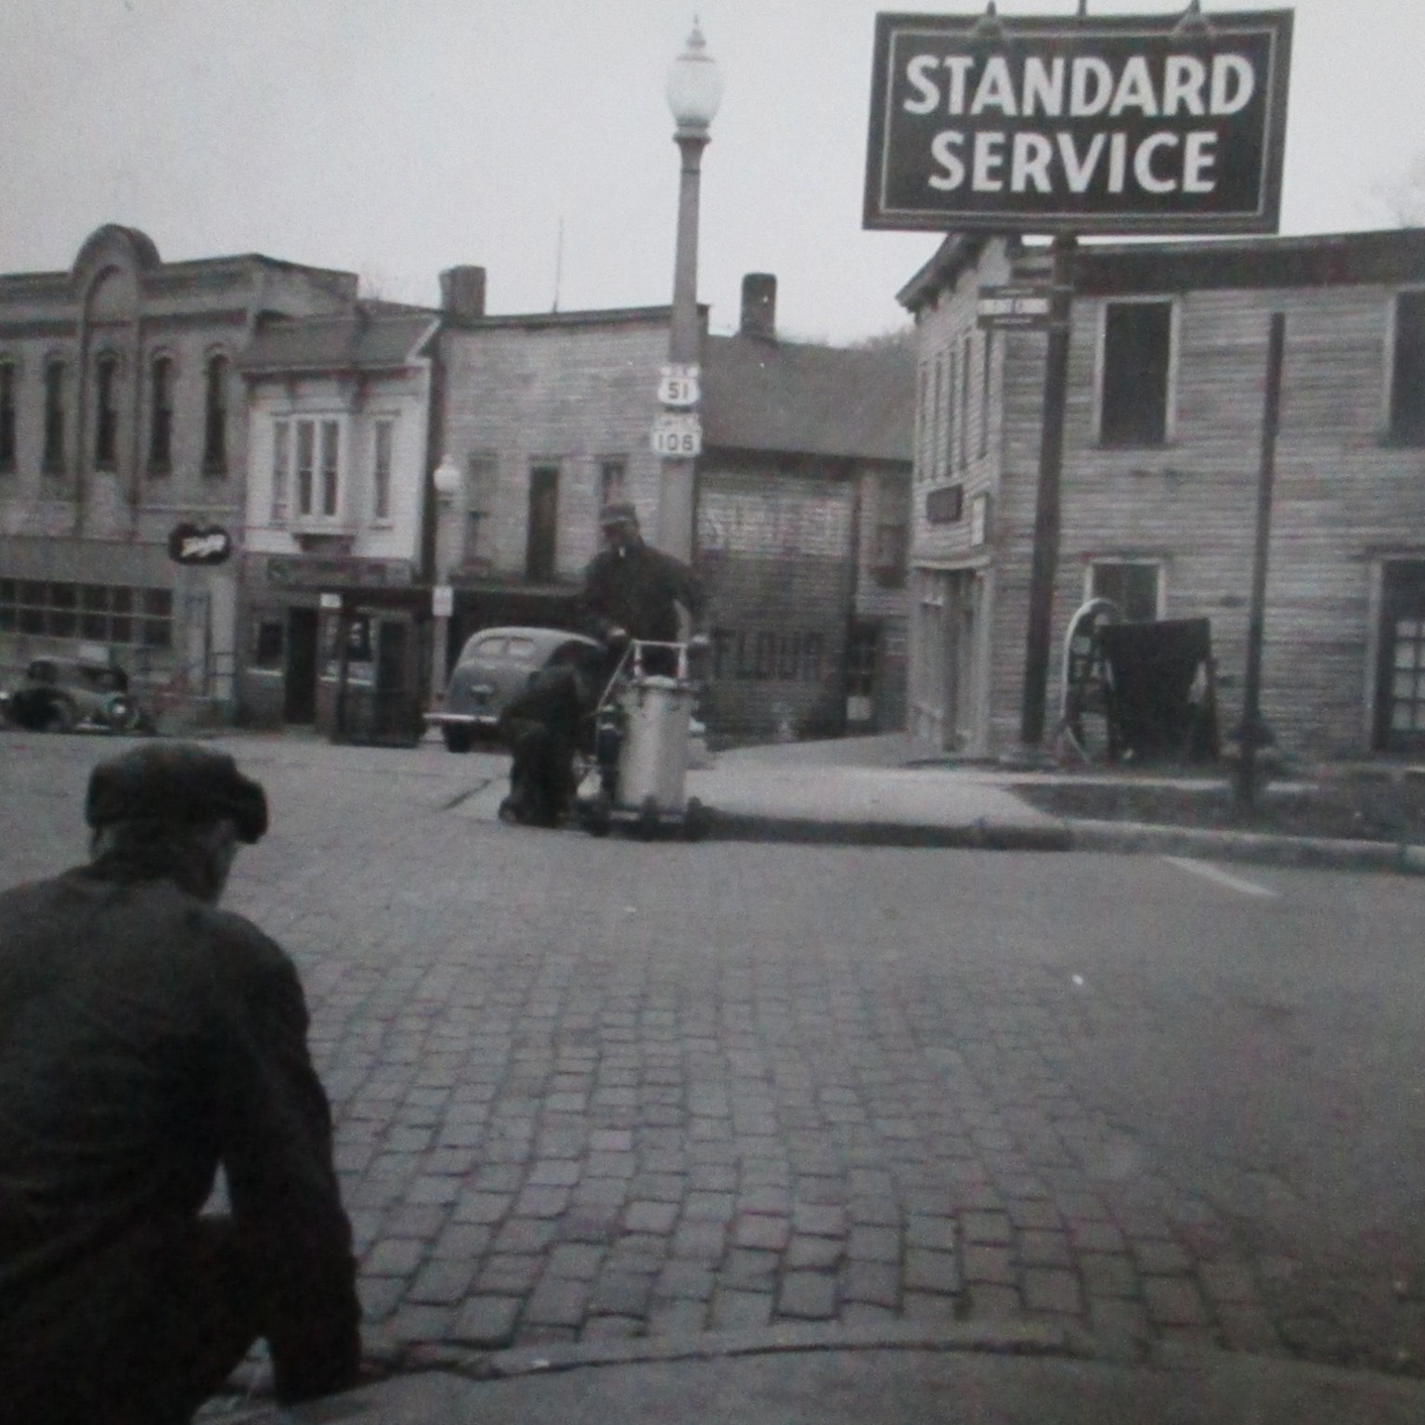 HISTORIC PHOTOGRAPH 4 OF 21: VIEW OF THE SOUTH SIDE OF MAIN STREET LOOKING EAST FROM FIFTH STREET, UNDATED. COURTESY OF THE STOUGHTON HISTORICAL SOCIETY.
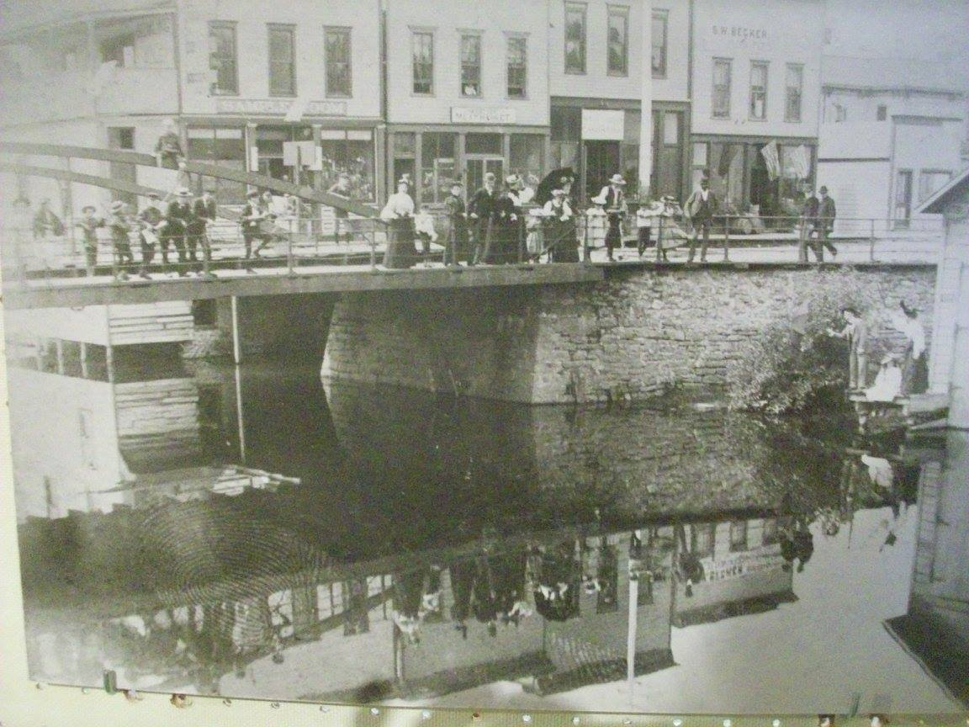 HISTORIC PHOTOGRAPH 5 OF 21: VIEW OF THE MAIN STREET BRIDGE OVER THE YAHARA RIVER WITH THE NORTH SIDE OF THE 200-BLOCK OF W. MAIN STREET IN THE BACKGROUND, UNDATED. COURTESY OF THE STOUGHTON HISTORICAL SOCIETY.
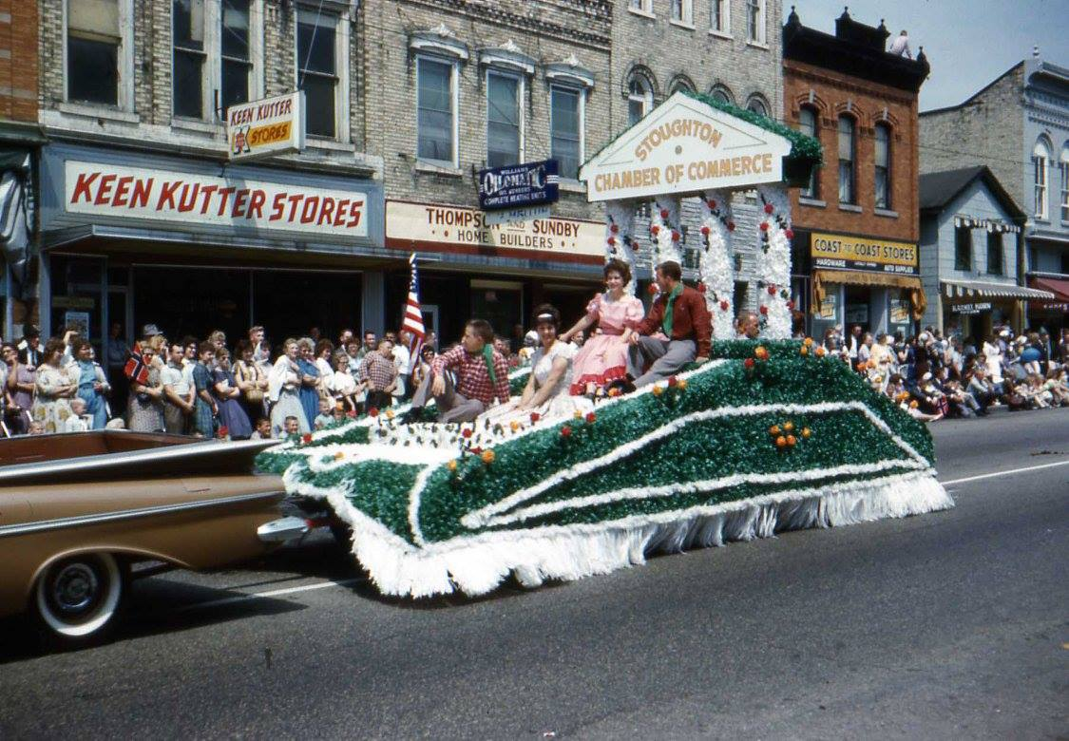 HISTORIC PHOTOGRAPH 6 OF 21: VIEW OF THE NORTH SIDE OF THE 100-BLOCK OF E. MAIN STREET, UNDATED. COURTESY OF THE STOUGHTON HISTORICAL SOCIETY.
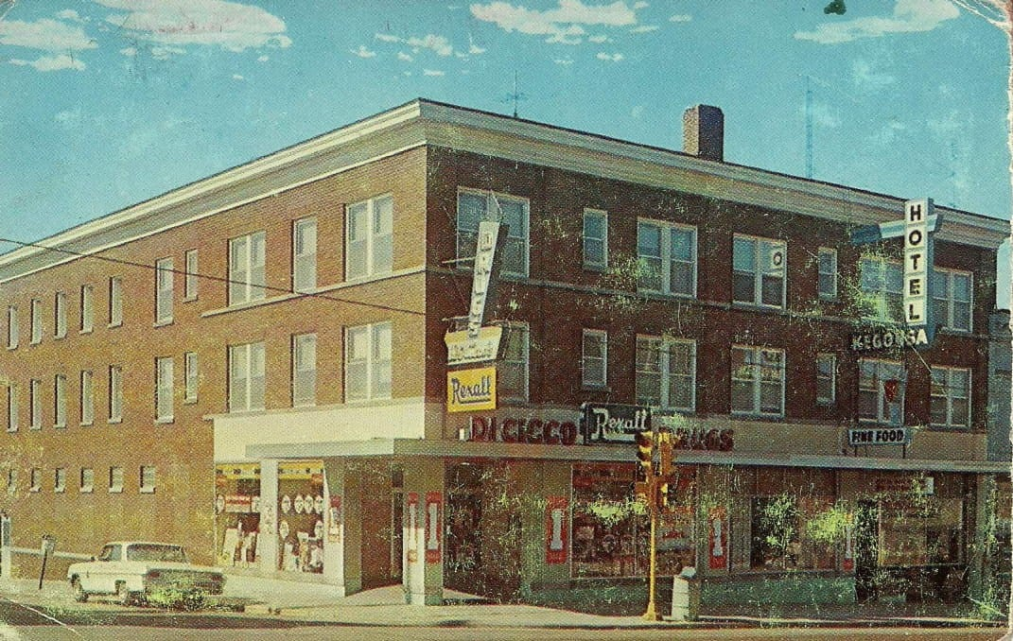 HISTORIC PHOTOGRAPH 7 OF 21: VIEW OF THE HOTEL KEGONSA AT 101 W. MAIN STREET, UNDATED. COURTESY OF VINTAGE STOUGHTON.
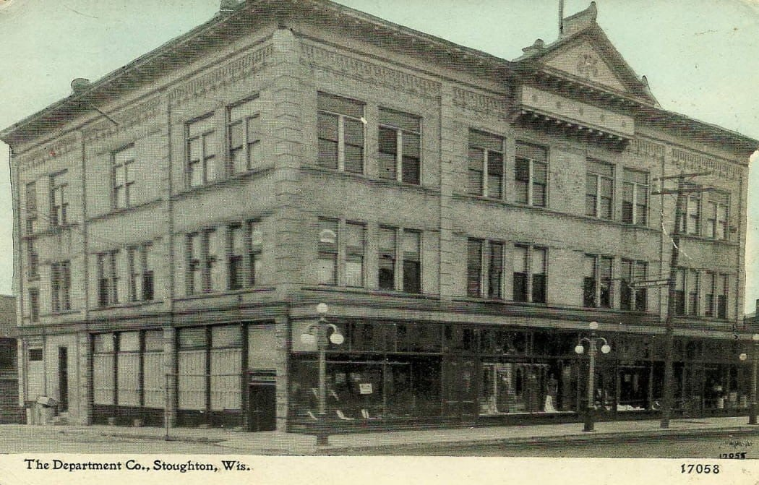 HISTORIC PHOTOGRAPH 8 OF 21: VIEW OF THE DEPARTMENT CO BUILDING AT 201 W. MAIN STREET, UNDATED. COURTESY OF VINTAGE STOUGHTON.
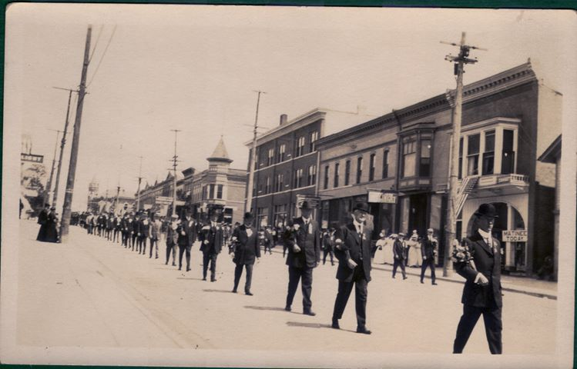 HISTORIC PHOTOGRAPH 9 OF 21: VIEW OF THE SOUTH SIDE OF THE 100-BLOCK OF W. MAIN STREET, UNDATED. COURTESY OF VINTAGE STOUGHTON.
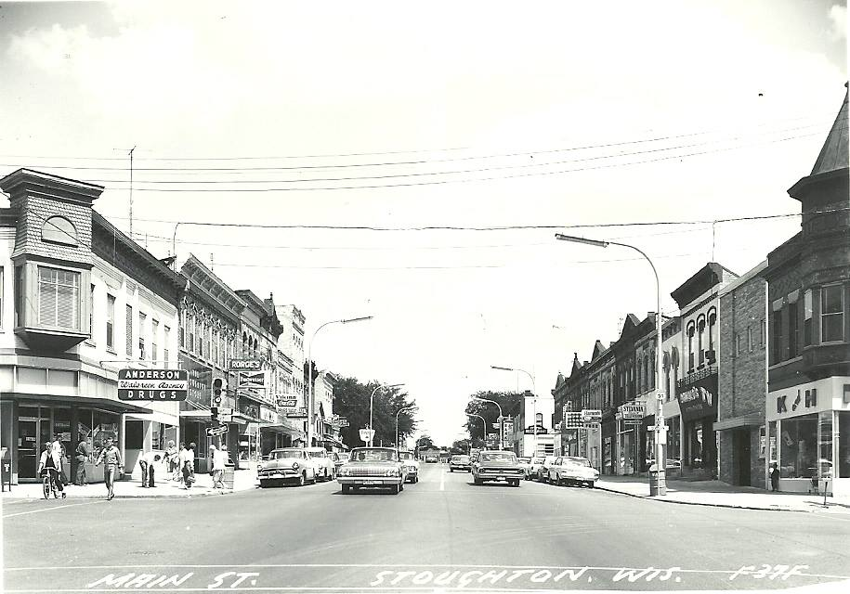 HISTORIC PHOTOGRAPH 10 OF 21: VIEW OF MAIN STREET LOOKING EAST FROM DIVISION STREET, UNDATED. COURTESY OF VINTAGE STOUGHTON.
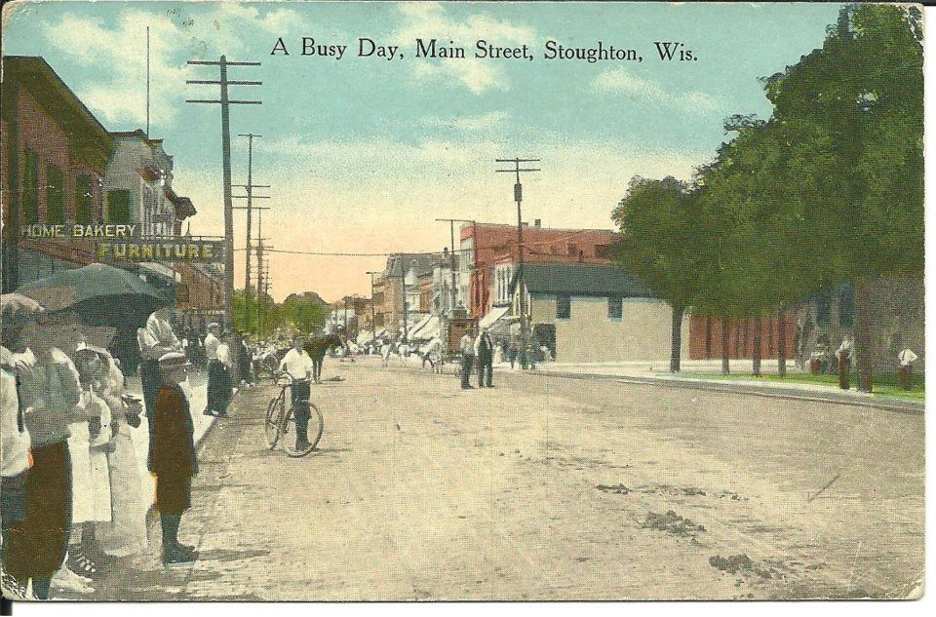 HISTORIC PHOTOGRAPH 11 OF 21: VIEW OF MAIN STREET LOOKING WEST FROM APPROXIMATELY 243 E. MAIN STREET, U NDATED. COURTESY OF VINTAGE STOUGHTON.
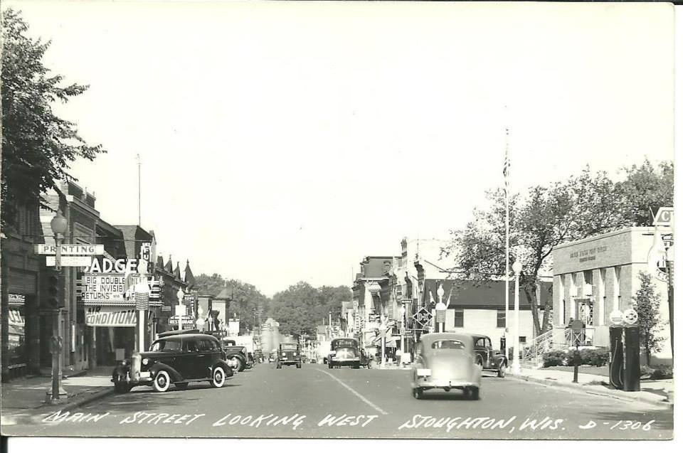 HISTORIC PHOTOGRAPH 12 OF 21: VIEW OF MAIN STREET LOOKING WEST FROM FOURTH STREET. COURTESY OF VINTAGE STOUGHTON.
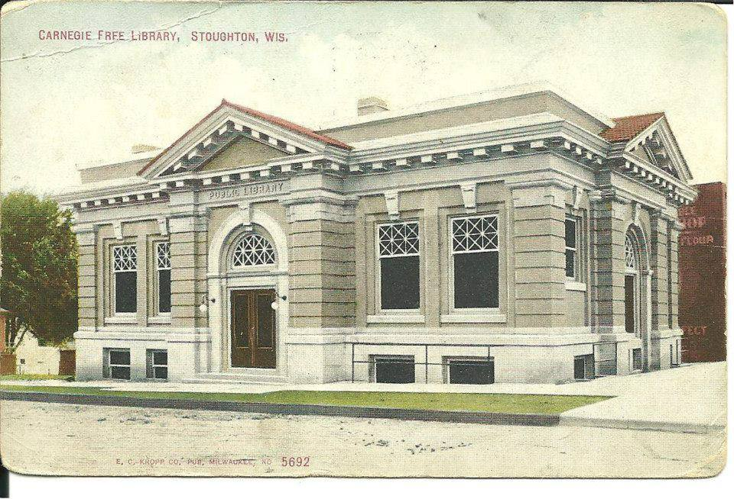 HISTORIC PHOTOGRAPH 13 OF 21: VIEW OF THE STOUGHTON PUBLIC LIBRARY AT 304 S. FOURTH STREET, UNDATED. COURTESY OF VINTAGE STOUGHTON.
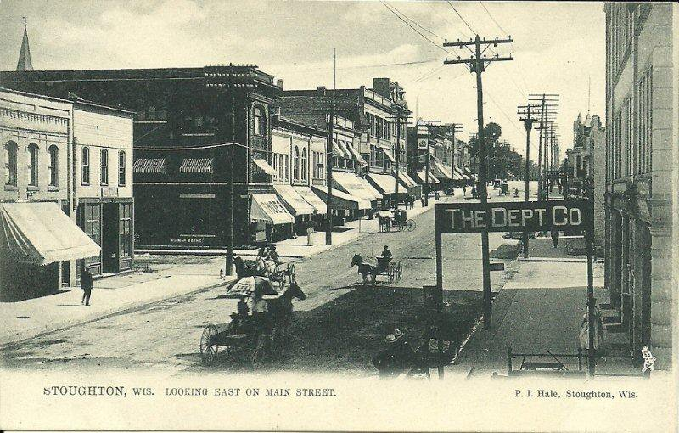 HISTORIC PHOTOGRAPH 14 OF 21: VIEW OF MAIN STREET LOOKING EAST FROM THE SOUTHEAST CORNER OF THE MAIN STREET BRIDGE OVER THE YAHARA RIVER, UNDATED. COURTESY OF VINTAGE STOUGHTON.
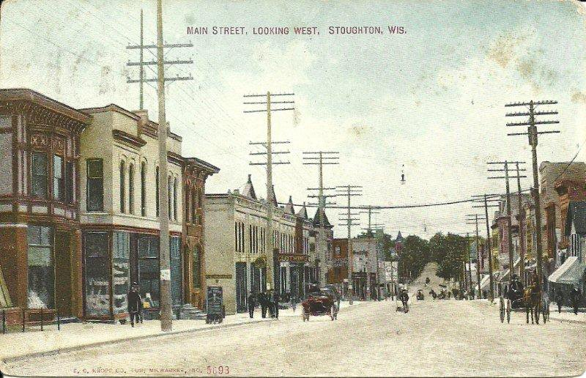 HISTORIC PHOTOGRAPH 15 OF 21: VIEW OF MAIN STREET LOOKING WEST FROM APPROXIMATELY 243 E. MAIN STREET, UNDATED. COURTESY OF VINTAGE STOUGHTON.
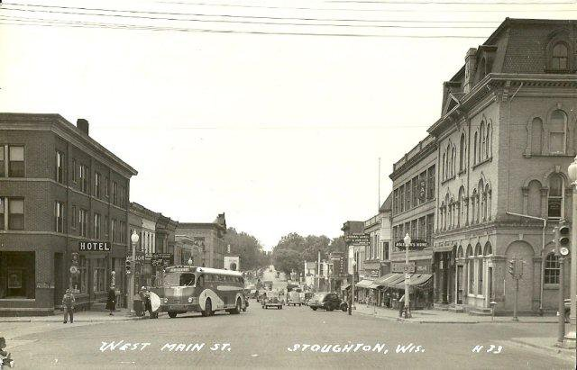 HISTORIC PHOTOGRAPH 16 OF 21: VIEW OF MAIN STREET LOOKING WEST FROM DIVISION STREET, UNDATED. COURTESY OF VINTAGE STOUGHTON.
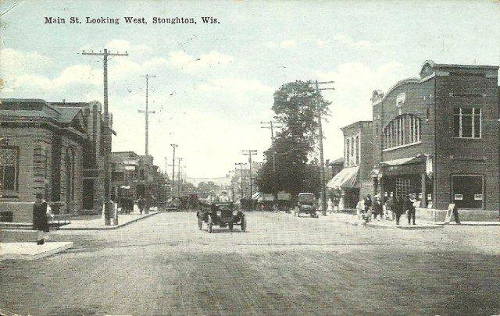 HISTORIC PHOTOGRAPH 17 OF 21: VIEW OF MAIN STREET LOOKING WEST FROM FOURTH STREET, UNDATED. COURTESY OF VINTAGE STOUGHTON.
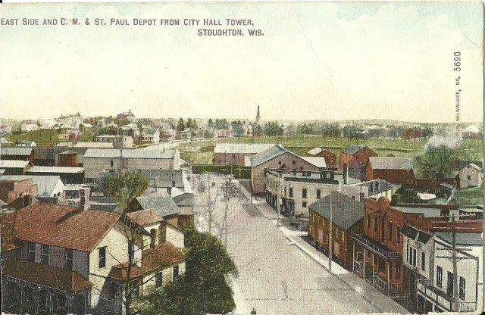 HISTORIC PHOTOGRAPH 18 OF 21: VIEW OF MAIN STREET LOOKING EAST FROM CITY HALL TOWER, UNDATED. COURTESY OF VINTAGE STOUGHTON.
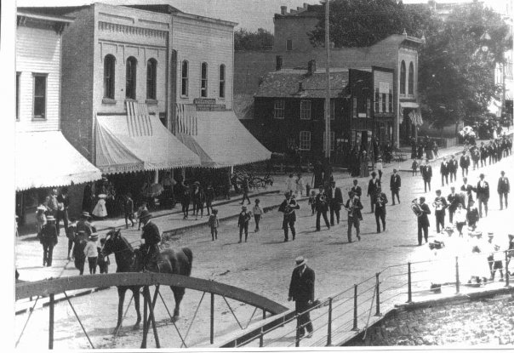 HISTORIC PHOTOGRAPH 19 OF 21: VIEW OF THE NORTH SIDE OF THE 100 AND 200 BLOCK OF W. MAIN STREET, UNDATED. COURTESY OF VINTAGE STOUGHTON.
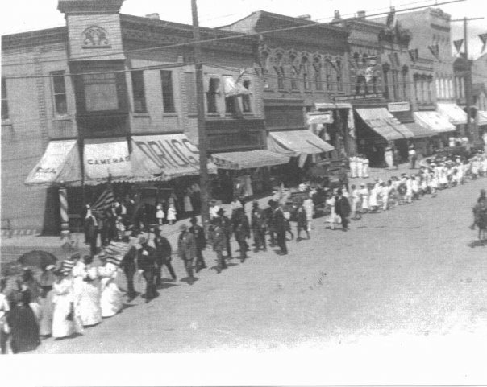 HISTORIC PHOTOGRAPH 20 OF 21: VIEW OF THE NORTH SIDE OF THE 100-BLOCK OF E. MAIN STREET, UNDATED. COURTESY OF VINTAGE STOUGHTON.
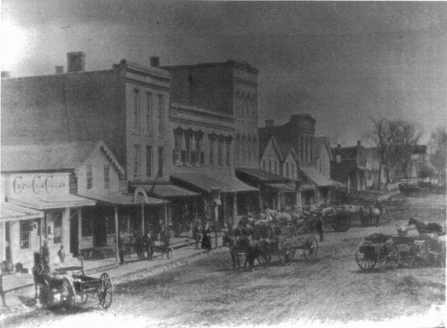 HISTORIC PHOTOGRAPH 21 OF 21: VIEW OF THE NORTH SIDE OF THE 100-BLOCK OF E. MAIN STREET, UNDATED. COURTESY OF VINTAGE STOUGHTON.

