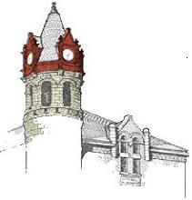 | OFFICIAL NOTICE AND AGENDA  Notice is hereby given that the Redevelopment Authority of the City of Stoughton, Wisconsin will hold a regular or special meeting as indicated on the date, time and location given below.
Meeting of the:  Date /Time: Location:  Members: | Redevelopment Authority of the City of Stoughton  Wednesday, October 9, 2019 @ 6:00 p.m.  Old City Hall, Hall of Fame Room, 381 E. Main Street  Regina Hirsch, Carl Chenoweth, Roger Springman, Lukas Trow, Dale Reeves,  Ozzie Doom and Pete Manley

Call to Order

1. Communications

2. Public Comments

3. Approval of minutes from September 11th, 2019 meeting

4. Finance Report

5. Old Business
  - Discussion on Real Property Valuation report provided by Great Lakes Advisory Group
  - Update on Developers Agreement progress
  - Update on Redevelopment Plan, including additional parcel options
  - Update from Downtown Revitalization Subcommittee

6. Topics for November 13, 2019 meeting

7. Adjourn

NOTE: An expanded meeting may constitute a quorum of the Council.
If you are disabled and in need of assistance, please call 873-6677 prior to this meeting.

